Hellingly Neighbourhood Development
Referendum Plan
2018 to 2028

February 2021

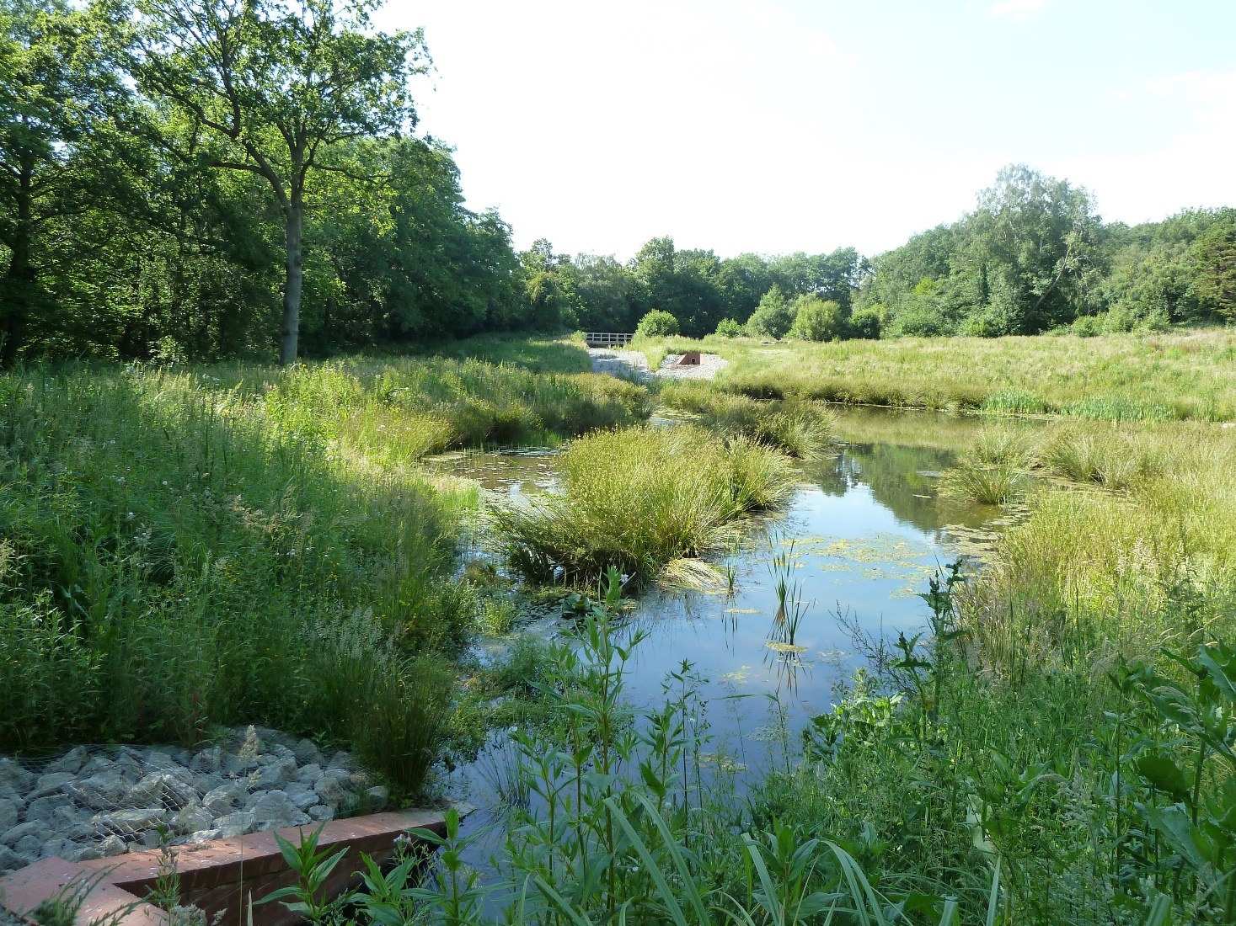
Hellingly Neighbourhood Development Plan – Introduction

The Localism Act of 2011 has been heralded by Government as giving communities direct power to develop and deliver a shared vision for their neighbourhood and deliver the sustainable development they need.

For the first time this Act introduced new powers to enable local communities to shape and influence development in their area through the production of Neighbourhood Development Plans. These Plans can set out policies and proposals in relation to developments and use of land within a particular area.

Through the Localism Act such plans, once successfully adopted form part of the statutory Development Plan for the area and carry material weight in the determination of planning proposals.

Neighbourhood Development Plans must still however have regard to National Planning Policy and should not be in conflict with the Local Plan (in this case the Wealden Local Plan 1998). They should seek to support, rather than prevent, growth.

After completing all of its necessary consultation stages the Hellingly Neighbourhood Development Plan (NDP) was submitted for examination by an independently appointed Examiner. The role of the Examiner is to ensure that the Plan meets all of the necessary legislative requirements, including; having regard to National Planning Policy, contributing to sustainable development, and being in general conformity with the Strategic Policies of the Development Plan for the area. In addition to the matters referred to above, the basic conditions that the NDP has to comply with also includes the requirement that it should be compatible with EU obligations and human rights legislation and further that it does not breach requirements of the Conservation of Habitats and Species Regulations 2017.

The examination of the NDP was held by way of a Public Hearing on 18 February 2020 to which members of the public and other interested parties were invited. Following this Hearing the Examiner concluded that the Plan should proceed to referendum subject to the Plan being amended in line with his recommended modifications. These are required to ensure that the NDP appropriately meets all of the basic conditions.

This version of the Hellingly NDP incorporates all of the Examiner’s recommendations to enable it to move forward to Referendum. The full text of the Examiner’s report is available on the Parish Council Website at https://www.hellingly-pc.org.uk/latest-news/examiner's-comments

The Plan also contains a number of specific Recommendations relating to the four principal settlements of the Parish as well as setting out, in Section 3 of the Plan, a number of further recommendations to providers of services such as health, waste water and education. The status of these is further explained at paragraph 103

These Recommendations are not Policies. They reflect local opinion as expressed in extensive public consultations which should be taken into account by service providers in the future planning and provision of their services. Policies have the suffix P and are coloured green. Recommendations have the suffix R and are coloured blue.
The Proposals Map consists of a series of individual Plans together with a composite Plan which clearly identify which areas of the Parish any particular NDP policy shall apply to.

The stated broad objectives of the Plan together with its draft Policies, proposals and recommendations seek to accommodate anticipated future growth in the most sustainable way by directing development to the most appropriate areas and by the protection of areas most sensitive to change.

At the end of each Policy there is a reference to the relevant Wealden Core Strategy policies and saved policies which underpin that particular policy and its proposed wording.

Wealden’s Development Plan contains a large number of Policies which are found within the District Council’s adopted Core Strategy 2013 together with the Affordable Housing Delivery Local Plan 2016 and various ‘saved’ Policies from the earlier Wealden Local Plan (1998). A web link to these is found at http://www.wealden.gov.uk/Wealden/Planning_and_Building_Control/Planning_Policy/Former_Local_Plan/Planning_Former_Local_Plan.aspx .

Additionally, the Plan seeks to retain as far as possible the essentially rural character of the parish whilst retaining the identity and character of its four principal settlements.

To quote from National Policy advice this Neighbourhood Development Plan “provides a powerful set of tools for local people to ensure they get the right types of development for their community”.

Map Showing Hellingly within Wealden District

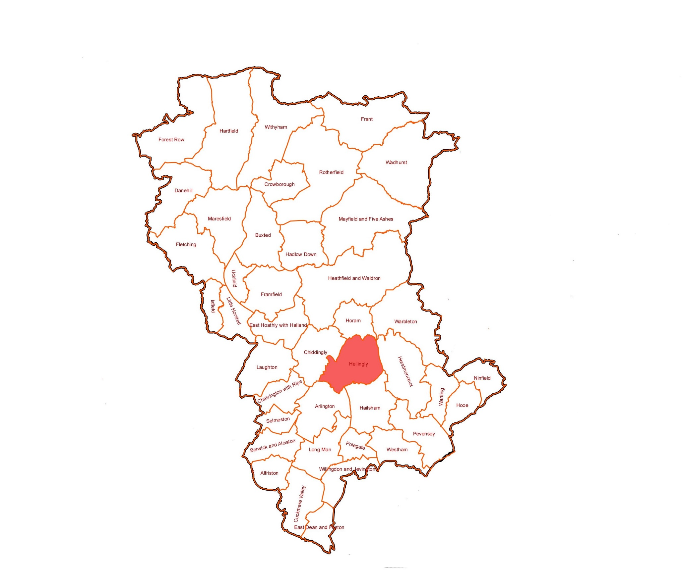
Contents

 | Page No.
- Introduction | 1
Section 1 – Protection of the Rural Character of the Area
- Landscape Quality and Character | 8
- Amenity Green Space/Local Green Space | 10
- Flooding – Including Surface Water Flooding | 13
- Natural Environment, Nature Conservation and Biodiversity | 15
- Hellingly’s Nature Conservation Assets – Developing Green and Blue Infrastructure Policies | 16
- Local Wildlife Sites | 17
- Biodiversity Opportunity Areas | 17
- Wildlife Hubs and Stepping Stones | 18
- Evidence for a Blue-Green Infrastructure Network | 18
- Support for the Rural Economy | 20
- Isolated Dwellings in the Countryside | 21
- Housing Provision and Housing Type | 22
Section 2 – Retention of the Separate Character and Identity of the four Main Settlements in the Parish (Hellingly Village, Lower Horsebridge, Lower Dicker and Roebuck Park)
- Introduction | 24
- Background | 24
- The Character and Identity of the four Settlements | 25
- Hellingly Village | 27
- Hellingly Village – Key Design Principles | 28
- Hellingly Village – Recommendations | 29
- Lower Horsebridge – Key Design Principles | 31
- Lower Horsebridge Recreation Ground | 34
- Lower Horsebridge – Recommendations | 34
- Lower Dicker – Key Design Principles | 35
- Lower Dicker – Recommendations | 38
- Roebuck Park – Key Design Principles | 39
- Roebuck Park – Recommendations | 42
- Heritage Assets and Non-Designated Heritage Assets | 43
Section 3 – Infrastructure
- Recommendations to Providers  - Roads and Transport  - Education  - Sport and Recreation  - Digital Connection  - Retail, Employment and Other Services | 45  45  46  47  48  49
- Conclusion | 49
- Section 4 – Implementation | 51
- Steering Group and Project Team Membership | 53
- Appendices | 54
- Maps (see separate index for detail) | 62

Index of Maps

 | Page No.
Map 1 – Area of Locally Valued Landscape | 62
Map 2 – Blue and Green Infrastructure | 63
Map 3 – Hellingly Village Area | 64
Map 4 – Lower Horsebridge Village Area | 65
Map 5 – Lower Dicker Village Area | 66
Map 6 – Roebuck Park Village Area | 67
Map 7 – Proposals Map | 68
Locally Designated Green Spaces
Map A – Hellingly Country Park | 69
Map B – Lower Horsebridge Recreation Ground | 70
Map C – Field Adjacent to Village Hall, Hellingly | 71
Map D – Lower Dicker Cycling and Playground | 72
Map E – Union Corner Allotments | 73

Note: the village area maps may well also show designated Local Green Spaces where relevant as well as boundaries of e.g. the ALVL.

Hellingly Neighbourhood Development Plan (NDP)

Introduction

- The NDP evolved with two simple but widely supported broad aims:

- To protect the rural character of the area

- To retain the separate character and identity of the four main settlements in the Parish (Hellingly Village, Lower Horsebridge, Lower Dicker and Roebuck Park)

- This part of the draft NDP is accordingly set out in two principal sections with text and background information setting out why these two broad aims are important for Neighbourhood Planning in Hellingly and how, by proposing particular policies and protections, these broad aims can be met.

- This NDP is intended to cover the period up to 2028. The essential vision of the NDP is:

“that the growth proposed for Hellingly Parish within the emerging Wealden Plan will have been successfully delivered, with all appropriate supporting infrastructure and in the most suitable locations locally. Hellingly will remain an essentially rural parish providing a green and accessible lung for the growing town of Hailsham.”

Section 1 – Protection of the Rural Character of the Area

- For the purposes of developing the NDP the whole of the Parish of Hellingly has been appropriately designated following publication and consultation by Wealden District Council. In this regard protection of the rural character of the Area can be read as synonymous with the rural character of the Parish.

- Following the extensive consultation exercises carried out as an integral part of developing an NDP for Hellingly Parish the broad aim of protecting the rural character of the area received wide support. This high level of support is reflected in both Phase 1 and Phase 2 Public Consultation Reports which are produced as supporting papers for the NDP itself. Indeed, from the responses to the questionnaires which were sent to all of those on the Parish electoral role 92% supported the stated broad aims of the NDP.

- As a rural parish lying immediately to the north of the rapidly expanding town of Hailsham Hellingly faces particular and significant challenge in meeting the broad stated aims of the NDP whilst reasonably contributing to meeting wider housing needs in Wealden District. Hellingly has therefore worked closely with Wealden Council in developing its Plan.

- The more recent development of Roebuck Park at some 450 units has contributed significantly to the 20% increase in the population of the parish over the last 5 years and current planning permissions now being built out at Park Road further contribute to a fear of rurality being lost and the parish becoming suburbanised.

- Neighbourhood Plans are required to have regard to National Planning Policy and to not be in conflict with the Local Plan (in this case the Wealden Local Plan 1998). Whilst it is therefore recognised that there will be growth within Hellingly Parish it is felt appropriate, in order to better guide any such future growth to the best and most sustainable locations, for the NDP to be developed in significant part showing where new development should be resisted – whether that be by reason of landscape quality, flooding, biodiversity, amenity or sustainability reasons.

- An NDP is considered to be a land use plan and as such it must also meet the requirements of the Habitats Directives and Regulations. Under these regulations competent authorities, in this case the Wealden District Council, have a duty to undertake an appropriate assessment of the NDP to assess whether it is likely to have a significant effect upon a European site.

- Where a likely significant impact is identified the habitat regulations promote the use of mitigation measures and avoidance of any potential damaging effects to the site.

- Following its Sustainability Appraisal, the Hellingly NDP was submitted to the District Council, as the competent authority, for the purpose of carrying out an appropriate assessment under the Habitats Regulations.

- Wealden’s assessment concludes that certain Policies within the NDP could result in a significant adverse effect on the Pevensey Levels SAC and Ramsar site and that the most appropriate way of avoiding or reducing any impacts is to provide a suitable policy.

Policy HNDPE – Habitat Regulations

Development either supported or proposed by policies or projects contained within the HNDP, or any other development that may come forward in the Neighbourhood Plan area, may only be permitted if it can be concluded that the proposals, either alone or in combination with other plans or projects, will not adversely affect the integrity of a European site. Any proposals for development must be accompanied by information to allow the competent authority to complete a full Habitat Regulations Assessment of the impacts of the development.

To ensure that development does not adversely impact the Pevensey Levels Special Area of Conservation (SAC) and Ramsar site, proposals for development may only be permitted where there is sufficient capacity at the relevant Waste Water Treatment Works or alternative foul water drainage solution. Where impermeable surfaces are proposed within the hydrological catchment area then mitigation, such as sustainable drainage systems, will be required to control the quality and volume of surface water run-off to a level that will avoid an adverse effect on the integrity of the SAC and Ramsar when considered both alone and in combination with other Plans or projects.

Landscape Quality and Character

- The landscape quality of the Parish of Hellingly has been the subject of a number of recent studies, including those commissioned by the District Council in seeking how best to explore the most appropriate areas for development.

- A Topic Paper summarising these study findings, along with more local knowledge of the topography, geology and landscape of the Parish has been prepared as part of the NDP process. This highlights the differences in landscape character between the northern and southern parts of the Parish

- The northern part of the Parish is categorised in the East Sussex County Landscape Assessment as forming part of the South Slopes of the High Weald. These are described as “an intricate and small landscape with a strong pattern of hedgerows” where “gentle valleys afford good views of the Downs”. Key characteristics include streams draining into the River Cuckmere, a close network of small woods and hedges, winding lanes with scattered farms, cottages and linear settlements often on ridges. The predominantly pastoral undulating southern slopes of the High Weald contrast with the more open arable low lying area to their south.

- Wealden has recently updated and published further evidence on landscape character and ecology as part of its emerging Plan. This identifies the key characteristics of discrete areas within the Parish described as Ridges and Slopes, Ridges and Valleys and Open Clay Vales. The study also notes previous work on accessible pastoral green space and the important links identified by the Cuckoo Trail and Wealdway long distance recreational route. In particular this study identified a number of areas of green infrastructure deficit associated with the urban area of Hailsham. These Wealden Studies have been instrumental in enabling the identification of those cherished landscapes that are highly valued locally, most sensitive to change and which the NDP seeks to protect.

- The NPPF confirms that the planning system should “contribute to and enhance the natural and local environment by protecting and enhancing valued landscape” and calls for “criteria based policies against which proposals for any development on or affecting wildlife of landscape areas will be judged” with “distinctions being made between the hierarchy of international, national and locally designated sites. It does not define “valued landscapes”.

- A number of NDPs have promoted the concept of ‘Locally Valued Landscapes’. The Proposal that the northern part of the Parish of Hellingly should be identified as such was supported by 94% of those residents who responded to the consultation questionnaire on the NDP. In developing this proposal, regard was had to the reported views of Examiners on what might justify such an identification.

- In some cases, Examiners have focussed on landscape quality. For example, in 2018 a site in Berkshire was accepted as a valued landscape because of its “quintessential English countryside” characteristics of attractive views, rolling topography, designated footpaths, trees and woodland. In others, the emphasis has been more on the extent to which the landscape is valued. For example, in 2017 a site in Essex which lacked public access but lay close to popular walking routes was held to have a “high value in that regard. Also in 2017, an Examiner considered the relationship between people and place in the wider context to be more helpful in assessing a valued landscape than simply focussing on whether key features of landscape character areas were present in and around the site.

- It is considered that the northern part of the parish is a locally valued landscape not only because it is an area of attractive and unspoilt countryside but, more particularly, because it provides a green lung for the rapidly expanding town of Hailsham, which will soon be, (if it is not already) the largest town in Wealden. It is proximate, easily accessible and highly valued by Hailsham residents. It is bisected by the Cuckoo Trail which runs between Polegate and Heathfield, (a former railway line now part of Sustran’s national cycleway network) from which several Wealden Walks and a network of local footpaths emanate. It is also traversed by the Wealdway long distance footpath. There is no other area around Hailsham which is comparable in terms of landscape character, accessibility and public usage.

- The Proposals Map accordingly identifies this as an Area of Locally Valued Landscape (ALVL). Its boundary has been drawn to reflect the distinction identified in both the County and District Council’s studies of the difference between the more wooded, undulating and predominantly pastoral slopes of the southern High Weald and the more open arable land to the south. The southern boundary of the ALVL follows (from west to east) the Bull River to the A267, Vicarage Lane, Mill Lane, Park Road and the southern edge of Park Wood as this is considered to be a more clearly identifiable line on the ground than that shown in the Landscape Studies.

Policy HNDP1 – Area of Locally Valued Landscape

Within the Hellingly Locally Valued Landscape Area as identified on Map 1 the inherent visual qualities and distinctive character of the area will be protected. The area is characterised by small fields with well-established species rich hedgerows. It contains numerous areas of surviving Ancient Woodland, some small and some large (e.g. Park Wood and Nobody's Wood) together with many shaws and copses dotted throughout this landscape. There are a number of traditional Sussex Ghyll woodlands, and many small ponds and water features. Whilst there is some arable use the land is mainly grassland used for livestock farming, very rural in character with few roads and a well-developed network of public footpaths providing impressive long-distance views over the Low Weald to the South Downs.

Development will be permitted if it is not detrimental to the rural character, scenic quality or visual amenities of the area and any adverse impacts can be satisfactorily mitigated.

Development will be permitted if it does not adversely impact the rural setting of public footpaths.

Long distance views of the South Downs from the public vantage points as shown on Map 1 will be protected from obtrusive developments.

Developments will be required to demonstrate that lighting proposals are the minimum required for security and or working purposes and that measures to minimise light spillage or glare have been taken.

(Core Strategy Policies – WCS13, WCS12. Saved Policies EN8, EN12, EN14, EN17)

Amenity Green Space/Local Green Space

- The recognition, identification and protection of green spaces within the parish is important not only to retaining the character, including the essentially rural character of the parish, but also in terms of the value that the community attaches to such spaces.

- There are a number of areas of green space within Hellingly that are valued for their recreational and amenity role in addition to the contribution that they make to local character and appearance, nature conservation, leisure opportunities and community value and use. These areas are additional to those nationally and locally designated sites such as Ancient Woodlands and Sites of Special Scientific Interest (SSSIs) but have local and specific importance in the context of Neighbourhood Plans.

- Their importance is primarily based upon their social, recreational and appearance value, but many also have indirect biodiversity value and can act as a physical or visual connection between other green spaces.

- National planning policy guidance encourages local communities through the production of local and neighbourhood plans, to identify for special protection green areas of particular importance to them. By designating land as Local Green Space local communities will be able to rule out new development other than in very special circumstances.

- The identification of such land (as Local Green Space) should be consistent with the local planning of sustainable development and complement investment in the provision of homes, jobs and other essential services.

- The NPPF emphasises that Local Green Space designation should be used

- Where the green space is in reasonably close proximity to the community it serves.

- Is demonstrably special to a local community and holds a particular significance, for example because of its beauty, historic significance, recreational value (including as a playing field), tranquillity or richness of its wildlife; and

- Where the green area is local in character and is not an extensive tract of land.

- Policies for managing the development of land within a Local Green Space should be consistent with policies for Green Belts. These aims include the prevention or check of the unrestricted sprawl of large built up areas, to prevent neighbouring towns from merging into one another and to assist in safeguarding the countryside from encroachment.

- Wealden’s recently published Open Space Study provides an area profile that includes Hellingly Parish and which identifies an under supply in the quantity of green space across Hellingly, Arlington and Hailsham. Under supply in allotments, amenity green space and parks and recreation grounds are highlighted. It is accordingly considered vital that existing valued facilities are protected and that opportunities be taken where possible to address acknowledged under provision of some 22ha.

- The NPPF sets out a number of criteria where the designation of an area as local Green Space will be appropriate.

- Within Hellingly Parish it is considered that there are a number of potential areas that are valued locally and which meet the criteria set down in national guidance. These candidates for designation as Local Green Spaces are set out below together with their reasons for designation in respect of meeting NPPF criteria.

- Hellingly Country Park (at Roebuck Park) – this important green space is in close proximity to the recent Roebuck Park Development and provides recreational, social and community value. It also holds historic significance as part of the former Hellingly Hospital grounds.

- Lower Horsebridge Recreation Ground – this well used recreation ground and playing fields provides a wide range of facilities for the local community (cricket, rugby, bowls and children’s play area).

- Field adjacent to Hellingly Village Hall – this field, part of Broad Farm ownership, has a long history of social and community use for the Festival of Transport, Circus, Long Dogs and Horse Carriages. It also comprises an important and integral part of the formally designated Conservation Area for Hellingly Village.

- Lower Dicker Cycling and Playground – An important recreational and leisure facility close to the community it serves.

- Union Corner Allotment Site, Lower Horsebridge – An important leisure, recreational, social and community place.

- These areas are designated as Local Green Space within the Hellingly NDP with the intention that they shall be protected for the community and their amenity value and also because they contribute generally to biodiversity and the local green infrastructure network. These designated green spaces are shown on Maps A to E within the NDP.

Policy HNDP 2 – Local Green Space

The following sites, as shown on Maps A-E, are designated as Local Green Spaces where development will be ruled out, except in special circumstances:

- Hellingly Country Park;
- Lower Horsebridge Recreation Ground;
- Field Adjacent to Hellingly Village Hall;
- Lower Dicker Cycling and Playground; and
- Union Corner Allotments Site, Lower Horsebridge.

(Core Strategy SPO11, WCS13 Saved Policies LR1, LR3, LR5)

Flooding – Including Surface Water Flooding

- Flooding is a particular and regular occurrence within the parish including surface water flooding which in the past has not been covered in a comprehensive way by official (Environment Agency or East Sussex County Council) records or mapping and has hitherto relied upon local knowledge to identify both the scale, scope, location and regularity of the problem. The County Council as Lead Flood Authority (LLFA) and Wealden District Council are both committed to addressing this issue and now have more comprehensive records of local flood events.

- Hellingly Parish, particularly in the southern part sits on heavy Wealden clay. Hitherto there has been little recording of surface water flood events on farmland.

- The problem of surface water flooding is worsened by a number of related factors including the higher topography to the north from the southern slopes of the High Weald. Secondly, the scale of new developments within the Parish and where some proposed sustainable drainage systems have not proved wholly effective and thirdly, local concern and experience around the raising of levels on development sites to alleviate site specific problems which have merely transferred problems to adjacent land.

- Parts of the parish surrounding the Cuckmere and Bull rivers that run through the parish are particularly susceptible to both fluvial and surface water flooding. Both the Cuckmere and the Bull rivers are flash rivers that are prone to significant and rapid rises in water levels following periods of heavy and prolonged rain. Both rivers are also affected by tidal block when there is high tide at the coast.

- East Sussex County Council, Wealden District Council and Parish Councils in southern Wealden are working together to understand the extent and nature of groundwater movement and flooding in the area, through a joint funded groundwater study. The outputs of this study will inform the LLFA’s approach to addressing the in-combination effects of local flood risk: including both interactions with new development and the effects of new development on existing communities.

- The NPPF confirms that

“inappropriate development in areas at risk of flooding should be avoided by directing development away from areas at high risk and where development is necessary, making it safe without increasing flood risk elsewhere” (NPPF February 2019 para. 155)

- Section 9 of the Flood and Water Management Act 2010 places a duty upon both the Environment Agency and the Lead Local Flood Authority to develop, maintain, apply and monitor a flood risk management strategy and specifies “flood risk” as risk from surface run off, groundwater and ordinary watercourses.

- The Preliminary Flood Risk Assessment (PFRA) was first published in June 2011 in response to the requirements of the 2010 Act and this is shown in the NDP Topic Paper on flooding. This map shows a cluster of flooding events clearly visible within the Parish largely composed of Southern Water flood incidents and Wealden District Council flood incidents. An area within the Hellingly Parish extending from Lower Dicker through Lower Horsebridge and up to Hellingly Village is also marked as being susceptible to surface water flooding. A photographic Appendix attached to HNDP Topic Paper 5 shows the particular and regular impact of this problem.

- The current East Sussex Flood Risk Management Strategy is a material consideration in planning decisions. As Risk Management Authorities, district and borough councils, as Local Planning Authorities, are under a duty to have regard to the LFRMS when delivering their functions (FWMA section 11(4)).

- A significant change to the regulatory regime took place in 2016 when a new Internal Drainage Board for the Pevensey Levels and the Cuckmere was established. The Pevensey and Cuckmere Water Level Management Board (PCWLMB) has issued byelaws which include the requirement for developers to apply for drainage consent where their proposals discharge to the Board’s district. This requirement applies both within and adjacent to the district boundary. Consequently, any development proposals that are likely to affect the Board’s interests should be discussed with the Board. It follows that to minimise the costs of acquiring discharge consent it is in a developer’s commercial interests to manage water on site more sustainably.

- Flood risk assessments for Hellingly should take particular account of local records, including those of surface water flooding and the flooding of agricultural land which have historically not been covered on the official records of East Sussex County Council as the responsible body in respect of flood risk.

- Assessments of risk from flooding for development purposes should accordingly seek to model for and rigorously cover assessments of local conditions carried out over a minimum of three occasions during the months of November through to the end of January when problems of flooding are most prevalent.

- Such assessments, given the accepted lifetimes considered for new developments should also model for and be aware of anticipated impacts of climate change where events now considered ‘extreme’ may in future become more routine. The Parish Council will work closely with the County Council as Lead Flood Authority and Wealden District Council to help develop policy to ensure that any risk of flooding from development within the Parish can be minimised or satisfactorily mitigated.

- The LLFA and the PCWLMB have operated a shared service in partnership when commenting on planning applications and engaging in the development plan process. All developers’ enquiries, therefore should be addressed to the Lead Local Flood Authority (ESCC).

- Given the risk present in the parish, the LLFA is looking to promote the use of its SuDS Decision Support Tool for Small Scale Development to assist developers promoting “minor” development in determining the most effective approach to drain their site. In accordance with the LFRMS the County Council, as LLFA, will review flood risk and drainage issues in the county to identify areas of critical drainage concerns. Sites and settlements within these areas will form the basis of additional guidance to this Strategy. The planning authorities will be advised to require developers to use the SuDS tool to guide the drainage design of minor development proposals in these areas (p26).

Policy HNDP 3

- Where required, Flood Risk Assessments will be expected to assess whether the development is likely to be affected by current or future flooding from any source, including surface water and assess whether it will lead to flooding elsewhere, taking into consideration measures being proposed to deal with these issues, particularly surface water run-off.

- There will be a presumption against land raise on development sites in areas identified as being at risk from any form of flooding, unless such mitigation measures are to be put in place to the satisfaction of the Local Planning Authority, in consultation with East Sussex County Council as lead flood authority and Pevensey and Cuckmere Water Level Management Board.

(Core Strategy SPO9, SPO10, WCS14, Saved Policies EN1, EN4)

Natural Environment, Nature Conservation and Biodiversity

- The conservation and enhancement of the natural environment together with the identification and designation of wildlife corridors that should be protected for their nature conservation and biodiversity interest was also strongly supported (94%) by responses to the consultation phases of the NDP.

- The parish contains a number of important sites which, through their formal designation, are afforded a level of environmental protection. These include sites identified as of county wide importance, (local wildlife sites) and a number of Ancient Woodlands identified on Natural England’s Inventory of Ancient Woodlands. These environmental assets are protected through the application of relevant policies and national guidance by Wealden District as the Local Planning Authority.

- Topic Papers 8 have been produced to support the provision of additional, more specific and localised policies to further protect the natural environment of the parish. This supporting evidence has been provided by the Sussex Biological Records Centre and Sussex Wildlife Trust and builds upon earlier work that identified the critical role played by the existence of wildlife corridors and hubs in ensuring a healthy and permeable natural environment to enable provision of areas for feeding, effective movement, breeding and spread of species.

- The challenges facing the natural environment from the impacts caused by development are significant. These include the loss of and further fragmentation of existing habitat as well as other direct impacts of noise, cat predation on local species, light pollution and disturbance caused by humans and human activity generally.

- The protection of and enhancement of these wildlife corridors and hubs is not only critical to maintaining the biodiversity and nature conservation of the parish but also in respect of providing these vital linkages to other sites to the north and most importantly southwards to the internationally designated site of the Pevensey Levels.

- The identification and protection of the areas is wholly consistent with advice in the NPPF para 170 which confirms that the planning system should contribute to and enhance the natural environment by

“minimising impacts on and providing net gains for biodiversity, including by establishing coherent ecological networks that are more resilient to current and future pressures.”

- National Guidance further encourages that, to minimise impacts on biodiversity, planning policies should

“identify, map and safeguard components of local wildlife rich habitats and wider ecological networks including the hierarchy of international, national and locally designated sites of importance for biodiversity, wildlife corridors and stepping stones that connect them and areas identified by national and local partnerships for habitat management, enhancement, restoration or creation”

and

“promote the conservation, restoration and enhancement of priority habitats, ecological networks and the protection and recovery of priority species and identify and pursue opportunities for securing measurable net gains for biodiversity.” (NPPF para. 174)

Hellingly’s Nature Conservation Assets – Developing Green and Blue Infrastructure Policies

- In 2011 the Government published Biodiversity 2020 ‘Strategy for England’s Wildlife and Ecosystem Services’ which itself built upon the earlier Natural Environment White Paper.

- The NPPF draws on these principles of protecting and enhancing biodiversity and creating ecological networks. It’s core principles essentially require that:

  - The planning system should contribute to and enhance the natural and local environment by establishing ecological networks that are more resilient to current and future pressures.
  - Setting out a strategic approach in Local Plans, planning positively for the creation, protection, enhancement and management of networks of biodiversity and green infrastructure.

  - Mapping local ecological networks, including the hierarchy of sites of importance, wildlife corridors and stepping stones for habitat restoration or creation and promotion of preservation, restoration and recreation of priority habitats.

- At the local level neighbourhood planning has the potential to be a key factor in identifying local priorities for nature conservation and ensuring these are taken into consideration in the planning process.

Local Wildlife Sites

- Formerly known as Sites of Nature Conservation Importance, Local Wildlife Sites (LWS) are identified at a county level and typically form a network of sites recognised as being of local nature conservation importance.

- The Parish hosts three Local Wildlife Sites. These have recently been re-surveyed and their citations revised in 2016 to include some changes and updated management recommendations.

CW14 – Hellingly Cemetery – includes considerable areas of species rich grassland

CW67 – Cowden Wood Meadow – an area of wet woodland and marsh with rare species with fern vegetation

CW97 – Jarvis’s, Nobody’s Wood and Park Wood complex – a large block of predominantly ancient semi natural woodland on the southern edge of the High Weald.

Biodiversity Opportunity Areas

- Biodiversity Opportunity Areas (BOA) are designed to promote a targeted landscape scale approach to conserving biodiversity in Sussex and identify the greatest opportunities for habitat creation and restoration as promoted by the NPPF.

- Three BOAs intersect with Hellingly Parish and are identified on the Proposals Map.

River Cuckmere habitat link. This BOA follows the mid reaches of the Cuckmere, eastwards towards the Pevensey catchment covering the natural floodplain of the river. It is an important area for a range of rare birds and provides opportunity for restoration of more naturally functioning floodplains and wetlands.

Cuckoo Trail habitat link. This link has benefits for people, urban wildlife and the migration and spread of species. It is particularly important in the conservation and enhancement of wildlife habitats and ecological networks between nearby built up areas.

Pevensey and Cuckmere Valley link. This BOA was identified to ensure that green corridors, ecological and hydrological links are retained between the headstreams of the Cuckmere and Pevensey Levels catchments. It includes land on four major development sites to the west and northwest of Hailsham including land in Hellingly Parish.

- Other assets outside these three BOAs e.g. rivers, streams, ponds, ancient and other hedgerows, veteran trees and ancient and other woodlands – also contribute positively to biodiversity and should be safeguarded where appropriate.

Wildlife Hubs and Stepping Stones

- Such areas are identified within the NPPF (para 174) as being important to the overall delivery of biodiversity objectives. A number of such hubs and green infrastructure corridors have been identified within Hellingly and are also shown on the Proposals Map.

Hurst Haven – leading from Park Wood to the Pevensey Levels. The Haven is one of the main tributaries leading to the internationally protected Pevensey Levels Special Area of Conservation. This parish hub provides the basis of a landscape buffer zone between north east Hailsham and the Puckeridge Stream to limit the human impacts on the Levels themselves.

Hellingly Mill – is currently recorded as the most biodiverse area of the parish, both in terms of species numbers and designated species present. The central position of this hub and its location on the main river add to its value as a blue-green corridor. The popular Cuckoo Trail passes adjacent to the site giving it added community value as part of a wider ecological network.

North West hub/Wellshurst – The Wellshurst golf course and surroundings, including the Cowden Wood Meadow LWS and the ancient woodland patches at Wallets/Old Barn Cottage to the south east also provide a significant hub for biodiversity. It is located in the High Weald Natural Character Area for notable expansive views and intrinsic landscape character of rolling hills, wooded ghylls and small fields with abundant hedgerows. Local footpaths add to its community value.

Evidence for a Blue-Green Infrastructure Network

- Taken together, the identification and existence of these natural assets (LWS and Wildlife Hubs and links) together with the BOAs provide the basis for Policies seeking to protect this Blue-Green Infrastructure.

- Such an approach was strongly supported by those responding to the NDP Questionnaire. Recent work undertaken to support the policies in the NDP has confirmed the benefits of such in ensuring the preservation of key natural capital functions essential for local people including:

- Clean air
- Noise reduction
- Water purification
- Access to nature
- Local climate regulation

- This work has enabled mapping of these key assets of the Natural Environment and these are shown on the Proposals Map as supporting the following policies.
Policy HNDP 4 – Green and Blue Infrastructure

Green and blue infrastructure assets as shown on Map 2 will be protected and enhanced by ensuring all development proposals within the areas identified on Map 2:

- Are based upon survey work carried out within the last 2/3 years or as stipulated in good practice guidance.

- Maintain and enhance the integrity of the green and blue infrastructure.

- On or immediately adjacent to green or blue infrastructure assets clearly demonstrate, through use of up to date ecological information, that proposals will not significantly harm the integrity or function of that feature and the benefits it provides. Where necessary proposals will include the identification of evidence and mitigation measures sufficient to avoid any harm to the green and blue infrastructure.

- Clearly demonstrate how the overall function and integrity of the green or blue infrastructure will be enhanced to provide net gains. Proposals for major development should include a management plan to ensure the effective long-term implementation and management of those green and or blue infrastructure assets.

(Core Strategy SPO1, WCS12, WCS13, Saved Policies EN12, EN13, EN14, EN15, EN16

- The NPPF confirms that the planning system should minimise impacts upon biodiversity and provide for net gains wherever possible. Whilst all developments have the potential to impact adversely on biodiversity it is the more significant proposals that are considered should be able to show specifically how any concerns have been assessed and addressed. It is therefore proposed that major developments, as defined by Annex 2 of the NPPF, should be required to produce an ecological management plan to ensure effective long-term implementation and management of biodiversity.

- Work undertaken with support from the Sussex Biodiversity Records Centre (SxBRC) has enabled the identification of critical green and blue infrastructure within the Parish. Additional work is being commissioned to evaluate the biological importance of Priority Habitats, the presence of notable species, and Opportunity Areas for enhancement and connectivity. This work will look to inform a Supplementary Planning Document to support the delivery of Policies within the NDP.

Policy HNDP 5 – Biodiversity

Biodiversity will be protected and enhanced by ensuring development:

- is informed by up-to-date ecological information and considers cumulative impacts as far as it is appropriate, having regard to the scale and nature of development and its impact on the wider ecological network.

- where appropriate, contributes and takes opportunities to improve, enhance, manage and restore biodiversity so that there is a net gain in biodiversity including through the creation of new protected sites and locally relevant habitats and incorporating biodiversity features within developments, such as nesting bricks, species friendly planting, bat boxes, creation of ponds.

- minimises habitat and species fragmentation through appropriate design and maximises opportunities to enhance restore and connect natural habitats to increase coherence and resilience.

- schemes comprising major development will be required to produce an ecological impact assessment and a management plan that ensures effective long-term implementation and management of biodiversity features.

(Core Strategy SPO1, WCS12, WCS13, Saved Policies EN12, EN13, EN14, EN15, EN16

Support for the Rural Economy

- Much of the existing rural character of Hellingly is derived from farming activity and the mix of land use between agriculture, settlements and woodland. Whilst as described in the sections on landscape quality the agricultural use in the south of Hellingly is more dominated by arable than the smaller field sizes and more pastoral nature of land in the north it is undoubtedly the case that agricultural use contributes significantly to the overall rural character of the area.

- For the NDP to help meet the broad aim of retaining this rural character it is considered appropriate to provide a policy framework which supports a prosperous agricultural economy. Many farms within the parish have already successfully diversified their mainstream farming activities through for example, development of rural workshops, tourism and leisure uses. Continued support for diversification was identified in the HNDP Topic Paper on Farming as being crucial for the future of farming in the Parish.

- The NPPF (para 83) encourages planning policies to support economic growth in rural areas to create jobs and prosperity by taking a positive approach to sustainable new development. The guidance confirms that local and neighbourhood plans should enable:

- The sustainable growth and expansion of all types of business in rural areas both through conversion of existing buildings and well-designed new buildings.

- The development and diversification of agricultural and other land based rural businesses

- Sustainable rural tourism and leisure developments which respect the character of the countryside.

- Retention and development of accessible local services and community facilities such as local shops, meeting places, sports venues, open space, cultural buildings, public houses and places of worship.

- A number of those farmers attending the discussion group confirmed how vital their diversification had been and other land based rural businesses confirmed the value of uses such as equestrian and tourism/leisure to the overall maintenance of farming generally.

- The NPPF, in encouraging possible policies for diversification, does emphasise the need for proposals to respect the character of the countryside, for well-designed buildings and for developments to be sustainable. With these important provisos, such support should not compromise the retention of the rural character of Hellingly.

- Subject to compliance with these requirements and other policies within the NDP, Policy HNDP 7 seeks to support farm diversification and rural economic growth. This proposed approach was supported by 68% of those who responded to the NDP questionnaire sent to all Hellingly residents on the electoral register.

Policy HNDP 6 – Rural Economy

Proposals for the diversification and development of agricultural and other land based rural businesses will be supported. In supporting such proposals developments will be required to demonstrate safe and suitable access, well designed buildings and that the character of the countryside/rural area is not adversely affected.

(Core Strategy SPO1, Saved Policies DC5, DC6, DC7)

Isolated dwellings in the Countryside

- The NPPF confirms that to promote sustainable development in rural areas housing should be located where it will enhance or maintain the vitality of rural communities and that local planning authorities should avoid permitting new isolated homes in the countryside unless there are special circumstances.

- In response to a question in the early consultation on the NDP the majority (77%) of those who responded indicated that they would support a policy encouraging the provision of new homes for those wishing to farm or manage land within the Parish for agricultural or land management purposes.

- Unjustified isolated dwellings within the Parish could lead to a diminution of the rural character of the area which the Plan is aiming to conserve.

- Historically proposals have come forward for agricultural and other rural workers or businesses where a countryside dwelling has been argued as necessary to carry out the enterprise.

- Whilst not seeking to oppose genuine agricultural or rural land management start ups the essential need to live on the premises has been sometimes overstated and the designs and size of dwellings proposed have appeared beyond the means of those wishing to start up in farming.

- Sometime after the NDP was submitted for its examination the Government published specific guidance on the matter of rural housing and isolated homes in the countryside and as the matter is formally addressed in the NPPF (paragraph 79) it is not considered necessary to replicate such policy within the NDP.

Housing provision and housing type

- From the questionnaire responses received regarding support, or otherwise, for particular types of housing this was a question that received a relatively mixed response. However, in the light of the significant levels of growth recently experienced in the parish, very few residents (5%) felt that the NDP should seek to allocate more housing over and above that proposed in the Wealden Plan.

- There was a reasonably high level of support for homes for the elderly (51% of 186 respondents) and also for starter homes (37% of 135 respondents). In respect of housing types 23% of respondents supported provision of bungalows with a fairly even split supporting self build (13%), 1-2 bed (13%), 2-3 bed (15%) and 3-4 bed (12%). Support for larger 5 bed plus homes was markedly lower at 5%.

- The NDP, in acknowledging that a future Wealden Local Plan will set Policies for a mix of housing generally deemed appropriate for the District, would accordingly wish to particularly support those applications coming forward under Wealden’s allocations where i) the principle of development is acceptable, ii) which better reflect the views expressed on housing types in response to the NDP questionnaire.

- In this regard the NDP responses indicated a high level of support for the provision of homes for the elderly. These views were further detailed in discussion groups and where support for small single storey units with small gardens was envisaged. This type of accommodation being seen as potentially similar to that in the ‘Cedars’ development in North Hailsham.

- This type and design of housing could possibly be successfully accommodated to the north of Station Road where the scale, mass and form of existing residential development is substantially of bungalows of modest size.

- Elsewhere within the general housing allocations expected to be proposed through Wealden’s Plan the NDP would wish to encourage a high percentage of smaller starter homes, shared ownership homes and those for key workers. These categories of housing type were supported by 37%, 17% and 42% of respondents to the NDP questionnaire respectively.

Policy HNDP 7 – Housing Type

Proposals that provide for a high percentage of homes for the elderly and starter homes/shared ownership (2-3 bed or smaller) will be supported.

(Core Strategy SPO3, Saved Policies HG5)

- To promote the use of electric vehicles and reduce local air pollution, the following policy encourages the provision of electric vehicle charging points in new housing developments. This reflects the County Council’s own Guidance for Parking at New Residential Development with which all new development will be expected to comply.

- This approach and Policy is considered entirely consistent with the NPPF and its clear guidance that such features should be incorporated in new development proposals in order to encourage use of more sustainable forms of transport and reduce the impacts of vehicles upon air quality.

Policy HNDP 8 – Sustainable Transport

New housing development will be required to provide electric vehicle charging points. There should be at least one charging point per dwelling for houses and for flats which have an allocated parking space. For flats without an allocated parking space, provision should be made for a shared communal charging point.

Section 2 – Retention of the separate character and identity of the four main settlements in the Parish (Hellingly Village, Lower Horsebridge, Lower Dicker and Roebuck Park)

Introduction

- This section of the NDP sets out the background to each of the four settlements seeking to identify and define their special character and how by proposing particular Policies and policy criteria for each, their separate character and identity can be maintained.

- During the Phase 1 consultation period and as part of the various discussion groups held a number of residents expressed great concerns at the amount of development that had recently taken place within the Parish and at the amount of new development proposed to be built within Wealden District.

- Comments such as “Hellingly has been developed beyond recognition” and “I am worried that Hellingly will lose its rural charm” were commonplace together with concerns that “there is no demarcation of boundaries, Hellingly is now joined with Horsebridge and similarly that is joined to Hailsham”.

- It is unsurprising therefore that this second broad objective of the NDP, namely to retain the separate identity and character of the four main settlements in the Parish, received wide support. Neighbourhood Plans provide an opportunity for a locally built consensus of what is deemed appropriate for an area in terms of establishing what is important and should be retained and respected. It is also the case that modern off-the-peg designs within developments of all scales have led to concerns regarding the loss of local character and identity together with perceived losses of some potentially worthy buildings through redevelopment.

- Through its NPPF the Government has expressed its clear support for good design and confirms that good planning is indivisible from good design. In furthering its support for this the NPPF states that both Local and Neighbourhood Development Plans should develop robust and comprehensive policies that clearly set out the nature and quality of development that will be expected for the area.

- For the purposes of the Hellingly NDP it is considered that these policies should be based upon a clear understanding of the history, topography, identity and character of the area and its four principal settlements. This is to help ensure meeting one of the principal agreed objectives; namely retention of character and identity. This is considered wholly consistent with both the NPPF (National Policy) and the Wealden Local Plan adopted Core Strategy which confirms support for promotion of local distinctiveness through good design in all development.

Background

- In order to better identify and thus seek to retain those specific and defining settlement characteristics and buildings which have helped to shape the four principal settlements within the Parish the NDP commissioned detailed Village Character Assessments for each. These are produced as Topic Paper 7 to support the NDP.

- These describe the qualities and characteristics which are appreciated and valued by residents, local people and visitors. In so doing they also provide guidance for the Local Planning Authority, the Parish Council, developers and residents on what would be appropriate within new developments.

- In the context of this Hellingly NDP they help to provide an evidence base to develop policies and policy criteria which can then be used in the determination of future development proposals. Their aim is to help retain the character and identity of the settlements concerned.

- Although these statements draw upon the past to explain how this has shaped the present character of the village, the focus of the Village Character Statements is in looking forward to the future and probable character of the village then.

- This set of Statements has been prepared to support the NDP. It seeks to define what makes each settlement special, what contributes positively to their character and what should be protected and preserved. This includes identifying designated heritage assets and their settings together with opportunities for enhancement and what kind of development would be appropriate or inappropriate.

- The Policies and Policy criteria stemming from this work, together with the Village Character Statements themselves, form an important part of the NDP which, once adopted will form part of the Statutory Development Plan.

- Under section 38(6) of the Planning and Compulsory Purchase Act 2004 applications shall be determined in accordance will the Plan unless material circumstances indicate otherwise.

- Following the Policies proposed for each of the principal settlements within the Parish (Hellingly Village, Lower Horsebridge, Lower Dicker and Roebuck Park) there is also a number of Recommendations relating specifically to each settlement. These recommendations are made in response to important local concerns and issues identified through the NDP various consultation phases.

- As Recommendations rather than Policies it is intended that they will receive serious consideration however it is emphasised that as ‘Recommendations’ they cannot constitute a formal part of the NDP in respect of assessment of future development proposals.

The Character and Identity of the 4 Settlements

- Although Wealden District Council adopted the Wealden Design Guide as a Supplementary Planning Document (SPD) in 2008 this is a generic document that applies across the whole of the District. Within the SPD it identifies the key characteristics of the Low Weald – within which Hellingly Parish lies – and provides generic information on traditional materials and building types. However, it is not specific and was never intended to capture the identity and character of each settlement.

- Wealden District Council’s adopted Development Plan (Core Strategy 2013 and 1998 Local Plan) identifies four principal settlements within Hellingly Parish and these are reflected in existing adopted policies.

- It is however, acknowledged that other built up areas and development clusters exist within the Parish, not least in respect of newer developments or indeed significant sites currently under construction. Such areas have not however been previously recognised, as principal settlements in their own right either for reasons of size/critical mass, lack of any historic reference or indeed in some instances because development is so recent (indeed in some cases still subject only of planning consents), or essentially constitute a single residential use permission.

- These areas do however all benefit from the bespoke conditions and obligations attached to their original planning consents and from each of the Parish wide Policies set out in Section 1 of the NDP in preserving their environment and amenity.

- Topic Paper 7 – Village Character Assessments, has been produced in respect of the four principal settlements of the Parish, as reflected in the District Councils own Local Plan and sets down the reasons for the retention of their character and identity.

- Our Village Character Statements are settlement specific and where development is considered acceptable and provided it respects the character of that settlement the Policies proposed are supportive. The Statements help to build a better understanding between developers, the local community and the planners.

- A more detailed history of the evolution of the four settlements can be found within the Character Assessments themselves. This section of the Plan seeks to outline a brief appraisal of the village scape/built form as exists today followed by specific Planning and other development recommendations in the form of Policies and Policy criteria.

- Many small-scale extensions and alterations to residential properties are able to be undertaken without the need for planning permission under what are known as ‘permitted development rights’. Accordingly, the settlement specific policies relating to design principles and design criteria in this NDP can apply only to those proposals where planning permission is required. It is however also considered that they can provide useful guidance in design matters to those carrying out works under permitted development.

- These permitted development rights are granted by virtue of the various exemptions from the need for planning permission afforded by the Town and Country Planning (General Permitted Development Order) 2015. The content and complexity of the Order means that it is recommended to check with the Local Planning Authority before carrying out any works. The document can be found at the following link: http://www.legislation.gov.uk/uksi/2015/596/contents/made
Hellingly Village

- The present day village of Hellingly remains as a relatively small village settlement and intact historically. Ribbon development has been limited as the Village is enclosed to the south east and west by the Cuckmere River. It is also subject to flood risk. The absence of a defined Development Boundary (within which the principle of development is generally viewed as acceptable by the planners) together with a designated and recently expanded Conservation Area has, along with the presence of important listed buildings, also helped constrain new development.

- The church and churchyard are on raised ground and are the focus of the village from which its structure and form is created. Many of the properties have small front gardens adding interest to the street scene with a variety of building materials evident including red and grey brick, tile hanging, flint elevations and plain clay tiles to roofs.

- To the north of the church a row of cottages provides an intimate and attractive backdrop in a diversity of form and materials but with a predominance of the Sussex vernacular. This arrangement provides visual interest in the overall pattern and grain of development and adds greatly to the historic atmosphere and feel of the village. A number of properties have attractive perimeter hedges of yew and laurel adding a distinctive structural element to the scene and enhancing the character of the village.

- The sensitivity of the settlement and its landscape coupled with there being no development boundary, has generally protected Hellingly. Nevertheless, there is evidence of change that is causing a degree of degradation in the quality and character of the village. This includes loss of historic elements such as traditional windows, doors, enclosures, the application of false shutters and obtrusive siting of satellite dishes.

- Overall, the spatial arrangement, pattern and grain of Hellingly may well be harmed by inappropriate or excessive new development.

- To help ensure the retention of the identity and character of Hellingly village and protect it from inappropriate development new developments will only be permitted where the following Policy and Policy criteria are met. This focus on preserving the setting of the designated Heritage Assets and positively contributing to the character and appearance of the Conservation Area is consistent with the adopted Development Plan and NPPF and the duty placed on Planning Authorities by the Planning (Listed Buildings and Conservation Areas) Act 1990.

Policy HV1

New development within Hellingly Village Character Area, which requires the submission of a Design and Access Statement, will be expected to clearly demonstrate:

- How it conserves and contributes to the character and appearance of the designated Conservation Area including key views and vistas as shown on Map 3. Further, how it conserves and contributes to the retention of the character of Hellingly Village.

- How it protects the historic development pattern of the settlement and does not detract from this pattern. This should seek to also ensure retention of existing field patterns along with hedgerows and trees along boundaries.

- Supports the preservation and enhancement of designated heritage assets and their settings.

- Use of designs that respect traditional and locally distinctive materials including their usage such as plain clay tile for roofing materials and tile hanging.

Development that erodes the rural character of Hellingly and does not meet the above criteria will be refused except in exceptional circumstances. Where extensions or ancillary buildings are proposed these should also, in addition to the above criteria

- Clearly be subordinate to the host building and respect the setting of designated assets.

- Respect traditional and locally distinctive materials. Brickwork should match the bind and pointing of the host building.

- Where additional car parking or garages are proposed they should be unobtrusive.

(Core Strategy SPO2, Saved Policies EN19, EN20, EN21, EN22, EN27)

Hellingly Village – Key Design Principles

- The key design principles referred to in Policy HV1 regarding the contribution of proposed development to the conservation and character of the area are concerned with ensuring that the separate character and identity of Hellingly village is retained. Both the NPPF and Planning Practice Guidance clearly indicate that design quality is a crucial planning consideration on all sites – character and identity are key components of this. Through the Village Character Assessments and settlement specific Policies it is considered that a range of design criteria can be justified to assist in the development of schemes that can be successfully accommodated without diminishing character and identity.
Policy HV2 – Specific Design Criteria Hellingly Village

- Designs that do not respect local character, identity and distinctiveness will not be supported

- Roofs of extensions and ancillary buildings should match the pitch of the host buildings

- Front dormers and roof extensions should be resisted

- Use of matching tiles for roofs, extensions and tile hanging will be required

- Loss of traditional timber doors, canopies and windows will be resisted

- Removal of chimney stacks will be resisted

(Core Strategy SPO2, Saved Policies EN19, EN20, EN21, EN22, EN27)

- The enlarged Conservation Area was formally designated by the District Council in March 2017 and extends westwards to include Broad Farmhouse, northwards to include Hill Harbour House and eastwards to Hellingly Watermill. It now includes 35 buildings and structures of which 21 are statutorily listed as being of (national) architectural or historic significance.

- It would therefore be of concern locally that any proposal to significantly increase the number of structures within, a recently extended Conservation Area can be successfully accommodated whilst remaining true to the purposes of both this enlarged designation of the conservation and enhancement of Listed Buildings and their settings generally.

- The likelihood of being able to do so successfully is significantly further diminished when one considers that Hellingly is located on a low promontory between the confluence of two rivers, the Bull and the Cuckmere. The fields surrounding the village flood regularly and the flat floodplain around Hellingly is integral to its setting and character, affording views to the church from various vantage points, most notably along the A267.

Hellingly Village – Recommendations

- The following paragraphs set out the reasoning behind the Recommendations for Hellingly Village.

- Wealden District Councils recently adopted enlargement of the formally designated Conservation Area is welcomed. It now includes 35 buildings and structures, 21 of which are statutorily listed as being of architectural or historic interest.

- However, designation of a Conservation Area is not an end in itself but the start of a continuing process of preservation and enhancement. Section 71 of the Planning (Listed Buildings and Conservation Areas) Act 1990 states that:

“it shall be the duty of a Local Planning Authority from time to time to formulate and publish proposals for the preservation and enhancement of any parts of their areas which are Conservation Areas “and that those proposals” shall be submitted to a public meeting in the area to which they relate”

- No such proposals have been formulated or published at any time since the designation of Hellingly Conservation Area in 1972. In response to a written query on this issue Wealden’s Head of Planning and Environmental Services has confirmed how a Management Plan can set out how development pressure and neglect can be managed to ensure Conservation Areas retain their special qualities.

- Public concern has been expressed on a number of occasions about changes that have adversely affected the character and appearance of the Conservation Area, particularly in the closed churchyard. It is considered important in seeking to retain the character and identity of Hellingly Village that a Management Plan is now urgently prepared including proposals for the preservation and enhancement of the area. This would also meet National Policy which refers to such matters as a duty upon the Local Planning Authority rather than any discretionary power.

Recommendation 1 – HV R1

In line with National Policy and as a matter of urgency, Wealden District Council be requested to produce a Management Plan for the Hellingly Conservation Area in consultation with local residents, the Parochial Church Council, the Parish and County Council. Such Plan to include the closed churchyard and to produce positive proposals for the preservation and enhancement of the Conservation Area.

- The impact of traffic within Hellingly Village has also been mentioned often in the various responses to consultation on the preparation of the NDP. This includes concerns regarding use of local winding narrow roads as a cut through/rat run to the A22 in addition to the significant traffic congestion in the vicinity of the Village Hall and local primary school where the existing inadequacy of parking provision leads to a proliferation of cars being parked along local, in essence, country lanes.

- The District Council has long recognised the need for some form of traffic management scheme to be designed and implemented for Hellingly and indeed developer contributions have been collected for this purpose. What is now needed is for relevant bodies to produce such a scheme. Localised issues centred upon the problems especially prevalent at the primary school at the beginning and end of the school day are also referred to in the Education paragraphs in Section 3 – Infrastructure, of the Plan.

- Unfortunately, although a widely recognised problem, discussions with the local landowner to relieve parking pressure for the Village Hall by increased provision, through release of land have proved unsuccessful.

- Whilst the design and especially the implementation of traffic management measures may require additional resources, Section 106 developer contributions, together with future income from Community Infrastructure Levy (CIL) can help to ensure delivery of appropriate solutions. These might usefully consider more coordinated and consistent responses from appropriate bodies to the flooding of local roads within Hellingly Village in times of heavy rain.

Recommendation 2 – HV R2

Wealden District Council, East Sussex County Council as Highways Authority and Hellingly Parish Council are recommended to work in partnership through existing and proposed work programmes to explore issues and options associated with movement and access in Hellingly and bring forward proposals to alleviate existing and foreseeable future problems on the local road network.

Lower Horsebridge

- There is no reference to ‘Horsebridge’ or Little Horsebridge in the Doomsday Book of 1086. Horsebridge is a derivation of Herstbridge although how it became two smaller settlements (Lower and Upper) as both lie along the same route is not known. Both lie within the Manor of Michelham and were referred to as wastelands. They were once covered with woodland during the Middle Ages but the forests were depleted due to timber being required for building and to fuel local iron furnaces.

- Lower Horsebridge is located some 2.7km from Hailsham and straddles both sides of the A271 a historic route that connected with the A22 and ran between Battle and Uckfield. The route may have been in existence from medieval times but was formalised under the Turnpike Act of 1754. A Toll House was erected on the A271 close to the junction with North Street.

- The river Cuckmere meanders through the landscape of the Low Weald to the south and east of Lower Horsebridge. The tributary to the east and a drain to the south east is crossed by the A271 with the Cuckmere itself being crossed at ‘Mill Bridge’ and meandering on to a mill referred to as Horsebridge Mill. This structure, built in 1902 is currently unoccupied and lies outside of the settlement of Lower Horsebridge.

- The village and land surrounding are liable to flooding because of the proximity of the Cuckmere and its tributaries. Because of these natural constraints the field pattern has survived relatively well to both sides of the A271.

- Lower Horsebridge has evolved over time to its present form which is a combination of a nucleated settlement in the vicinity of North Street, with linear development. Over time the village has seen additional development extending northwards (along North Street) and to the south west on both sides of the A271. The southern section of the A271 in the centre of Lower Horsebridge remains largely undeveloped with a large recreation ground affording views southwards.

- A key feature of the settlement is its rural setting and context. This is very pronounced on the approach to the village and within its core where the southern side of the road is largely undeveloped and permits long views over the recreation ground and Low Weald landscape. The pattern of development to the north is generally loose enabling views of the trees and countryside beyond. In contrast post war infilling facing the recreation ground has added a somewhat suburban and discordant character.

- Lower Horsebridge is not designated as a Conservation Area and no designations have come forward from the Local Authority, nevertheless there are a number of buildings within the settlement that occupy key locations, lead as landmarks, create interesting townscape groups and possibly have earlier origins than their appearance reveals: these include the Kings Head, the Post Office, Rose Cottage and Burleigh Cottage.

- The 1998 Wealden Local Plan refers to Lower Horsebridge as “consisting primarily of inter-war and post war frontage development along the A271”. In this reference it is considered that the historical value and evolution of Lower Horsebridge has been underestimated and that the historical evolution and presence of some important listed and non-listed buildings within the settlement contribute greatly to its character and identity.

- Local distinctiveness derives from its historic landscape and pattern of uses, primarily pastoral farming. In recent times the role of the recreation ground has replaced some of this agricultural use but remains an important space in ensuring the character of the settlement is respected.

- In spite of being a settlement with no development boundary within the Wealden Local Plan and where, countryside policies of restraint prevail Lower Horsebridge is under threat from new housing developments in particular infill housing and possible new allocations on land east of North Street.

- There are locations where small scale development has been proposed as adjacent to the Kings Head and where well designed schemes may successfully be able to be accommodated.

- To help ensure the retention of the identity and character of Lower Horsebridge Policy LHB1 will apply to all new development.

Policy LHB1

Where the principle of new development within Lower Horsebridge Character Area is considered appropriate proposals will be required where appropriate to clearly demonstrate

- How it supports the preservation and enhancement of designated heritage assets and their settings.

- Acknowledgement of buildings that make a positive contribution to the settlement and its character and appearance through designation as locally listed buildings and show how the development has regard to the scale of loss or harm when balanced against the significance of the building.

- How the proposed development protects the historic development pattern and the key views and vistas as shown on Map 4.

- That there is no erosion of the sense of openness and rural character of the existing setting of the settlement.

- How it promotes the use of locally distinctive materials including brick, tile hanging and plain tiled roofs together with use of or retention of traditional windows, doors, porches and shop fronts where they exist.

Where new development is considered acceptable, subject to other policies within the NDP developments shall

- Ensure they respect the prevailing scale, mass, footprint, materials and appearance of positive and locally distinct buildings.

- Seek to ensure the retention of field patterns along with hedgerows and trees along boundaries.

(Core Strategy SPO13, Saved Policies EN14, EN18, EN27, LR1)

- Through the Village Character Assessments and settlement specific Policies it is considered that a list of design criteria can be justified to assist in the development of schemes that will retain the identity and character of Lower Horsebridge.

Policy LHB2 – Specific Design Criteria – Lower Horsebridge

- Designs that do not respect local character, identity and distinctiveness will not be supported

- New dwellings should not exceed two storeys in height

- Roofs should be pitched to no less than 40 degrees

- Front dormers and roof extensions should be resisted

- Extensions to existing dwellings should clearly be subordinate to the host building

- As a general principle gaps between existing buildings should be retained and not encroached upon or reduced

- Traditional features elements and proportions should be respected

(Core Strategy SPO13, Saved Policies EN18, EN27)

Lower Horsebridge Recreation Ground

- It is considered important in the context of this NDP that efforts be made to increase the capacity of existing facilities. The most recent Open Space Study (2017) demonstrated an even more extreme under provision within its Area Profile for the parishes of Hellingly and Arlington and Hailsham Town Council areas.

- The Lower Horsebridge Recreation Ground comprises a full-size rugby pitch, a smaller training rugby pitch, a cricket pitch, bowling green and equipped children’s playground. It is the main sports facility in Hellingly Parish and located next to the boundary with Hailsham.

- Recent housing development within the area arising from proposals in Wealden’s adopted Core Strategy has meant that the acknowledged open playing space deficiency in North Hailsham and Hellingly has increased significantly.

Lower Horsebridge Recommendations

- The following Recommendations for Lower Horsebridge stem from local issues and concerns raised.

- Because of the nature of Lower Horsebridge being traversed by the main A271 road it is considered important locally for further traffic calming measures to be designed and implemented. The sinuous nature of the A271 does make crossing difficult and it will be especially important to improve matters should enhancement of parking and provision of leisure/recreation facilities at the recreation ground come to fruition.

Recommendation 1 – LHB R1

Wealden District Council, East Sussex County Council as Highways Authority and Hellingly Parish Council will work in partnership through existing and proposed work programmes to explore issues and options associated with movement and access in Lower Horsebridge, with particular reference to car parking provision and the needs of pedestrians and cyclists.

Recommendation 2 – LHB R2

Proposals which provide additional land for leisure/ recreational use in the vicinity of Lower Horsebridge Recreation Ground will be welcomed.

Lower Dicker

- Lower Dicker is a dispersed linear settlement straddling the A22 from the Boship Hotel close to the Boship roundabout to the south at the junction with the A267 and the Golden Cross Hamlet to the west. Exception to this linear form occurs along roads running perpendicular to the A22 including Coldharbour Lane and Camberlot Road to the south side and Hackhurst Lane to the north.

- Analysis of historic mapping clearly demonstrates the varying influences upon the spatial character of Lower Dicker including deforestation and the formation of the early A22 through the Turnpike Act 1754. The quality of land and its enclosures as common land as well as the location of brick and tile kilns together with associated encroachment or, in a number of cases, grants of land from the Manor of Laughton have also had marked influence on settlement pattern.

- Because it does not follow the nucleated pattern of most settlements within the District any appreciation of its present form requires an understanding of this local history. Buildings tend to front onto the road with the houses predominantly being semi-detached pairs and short terraces interspersed with fields and hedges. Although having a semi urban appearance in parts, due to the presence of former brick fields and common the overall character of the area is better described as semi-rural.

- Two families were the dominant brick makers in the Dicker – the Guys and the Goldsmiths but by the end of the Napoleonic wars only 2 brick makers were left in business on the east side of the A22.

- In the mid-19th century Uriah Clark took over the Goldsmiths brickyard near Boship Green and turned it into the Dicker Pottery. This business merged with the neighbouring Boship Green Pottery and survived into the 20th century specialising to some extent in paving bricks but attempts to expand and modernise in the 1920s came to nothing. By the time the road transport took over from the railways the Dicker Brickworks had ceased production.

- Today some of the brickfields have reverted to agricultural use and the same stretch of road is accessed by Little Hackhurst Farm, Ade’s Farm, Caldicotts Farm. Parsons Grove Farm, Knights Farm and Palmers Farm.

- Within this linear settlement in a rural setting constant glimpses of farmland and more distant views southwards to the Downs contribute positively to the local character.

- There are a number of buildings within Lower Dicker that contribute positively to its character and identity and potentially meet a number of the criteria for local listing. Where buildings are considered to display positive attributes such as the Zoar Chapel and the late 19th century red brick houses with decorative work and some buildings with tile hanging these can be considered as non-designated heritage assets with appropriate policy references to help ensure retention of their character and identity.

- Although Wealden District Council has acknowledged Lower Dicker as having a distinctive character derived from its historic land uses its local distinctiveness has perhaps been undervalued. It has certainly been under threat from modern infill developments and housing schemes which over time have begun to erode the unique character and appearance of the settlement. This despite it being a settlement with no identified development boundary in the Wealden Plan and where countryside policies of restraint prevail.

- For the purposes of this NDP and to help ensure the retention and character of Lower Dicker the following Policy will apply to development that is otherwise considered appropriate.
Policy LD1

Where considered acceptable in principle new development within Lower Dicker Character Area will be required where appropriate to clearly demonstrate

          - How it supports preservation and enhancement of designated heritage assets and their settings.

          - Acknowledgment of buildings that make a positive contribution to the character of the area and its appearance through designation as locally listed buildings and how their scheme has regard to any scale of loss or harm, when balanced against the significance of the building. This includes the Zoar Chapel.

          - How it protects the historic pattern of development clusters of built form and the important gaps between and views of the countryside between and beyond as shown on Map 5.

          - No erosion of the sense of openness and rural character of the settlement.

          - Where new development is considered acceptable, respect for the prevailing scale, mass form materials and appearance of positive and locally distinct buildings.

          - Use of locally distinctive materials including brick, tile hanging and plain tiled roofs.

          - That, in the case of modern or contemporary buildings that are acceptable in principle, they respect the prevailing settlement pattern and grain are of high quality and make a positive contribution to the identity of Lower Dicker.

          - Retention of existing field patterns along with hedgerows and trees along boundaries.

(Core Strategy SPO13, Saved Policies EN14, EN18, EN27)

- Through the detailed Village Character Assessments carried out to support work on retaining the identity and character of the settlements within the Parish the following design criteria will apply.

Policy LD2 – Specific Design Criteria – Lower Dicker

- Designs that do not respect local character, identity and distinctiveness will not be supported

- New dwellings should not exceed two storeys in height

- Roofs should be pitched to no less than 35-40 degrees

- Front dormers and roof extensions should be resisted

- Extensions to existing dwellings should clearly be subordinate to the host building

- Gaps between existing buildings should be retained and not encroached upon or reduced

(Core Strategy SPO13, Saved Policies EN18, EN27)

- It is considered that the A22 corridor in Lower Dicker offers some scope for future employment potential. As part of the NDP process the Parish Council commissioned a series of character assessments of the principal settlements within the Parish including the one for Lower Dicker that provides a detailed assessment and identification of its more important features. It is accepted that the District Council will undertake its own character assessment of the area as part of any new local plan. The Parish Council looks forward to working closely with the District Council in developing policies to help implement the potential for employment growth whilst respecting local character and identity.

Lower Dicker Recommendations

- The following Recommendations for Lower Dicker reflect concerns and issues raised during preparation of the NDP.

- Traffic, both its volume and speed together with the associated adverse impacts from pollution does unfortunately have a significant impact along this stretch of the Dicker. Whilst recent endeavours to slow through traffic and improve the safety for road users have had benefit more could be done to improve the lives of residents. Issues of air pollution caused by traffic remain a concern and one which will only increase with the increasing use of the A22.

Recommendation 1 – LD R1

That East Sussex County Council together with those bodies responsible for the monitoring of air pollution levels be requested to increase their efforts in the monitoring of traffic impacts in the area to design and implement solutions to enhance road safety and reduce traffic generated local air pollution issues. Such schemes to be the subject of widespread consultation prior to their implementation.

Roebuck Park

- Roebuck Park village development occupies the site of the former Hellingly Hospital. The hospital originally known as the East Sussex County Asylum, lies on slightly elevated ground to the north of Hailsham and the complex was built on 400 acres of land that was formerly the Park Farm near Hellingly Village.

- The hospital was closed in 1994 and the site and buildings lay unused until 2010 when work commenced to develop a large proportion of the land for housing with approximately 450 homes.

- The area identified on the approved Masterplan as the ‘village centre’ has not yet been built out. This element was designed to act as a focus for the new settlement and to connect the residential user to the retained original hospital buildings. Implementation of this remains important if the development is not to become a dormant ‘suburban village’.

- The original parkland that formed the grounds to the hospital complex was laid out in 1903 by the accomplished Kew Gardens landscape architect William Goldring. The grounds fell into a poor state of repair after the closure of the hospital however much of the structure remained and was largely restored as part of the Roebuck Park development.

- The historic focus of Roebuck Park was the hospital buildings and landscaped grounds and a number of the original buildings remain to provide reference to this period in the evolution of the village.

- To the north of the retained hospital buildings and The Drive is an area of ancient woodland known as Park Wood that provides an attractive backdrop to the village and is an important landscape feature in the village and wider area. A number of historic farm buildings to the south, including Park Farm on New Road also formed part of the hospital estate. These buildings remain on the edge of open countryside.

- The new development along The Drive covers some 25 hectares of which 13.75 hectares is a community parkland now owned and managed by Hellingly Parish Council. This area includes play areas, allotments, sports pavilion and cricket green. The built development is essentially contained in 2 areas, each having a distinctive style and layout wherein the park remains the central focus of the settlement.

- Properties on the southern fringe of Roebuck Park have elevated and commanding views over the parkland and the new residential buildings have sought to adopt typical Victorian, as well as some of the hospital vernacular detailing roof pitch and materials. The lower Roebuck Park area draws on more traditional Sussex materials and detailing with tile hanging, brick and clay tile roofs. The streets are predominantly orientated east west providing a physical and visual connection with The Drive and the parkland.

- The landscape structure of the parkland, woodland and surrounding farmland is a much valued, sensitive and important characteristic of the area. The relatively recent development of Roebuck Park has created an attractive parkland development albeit quite dense and urban in its rural context. Inadequate and poorly conceived parking provision does detract from some parts of the development.

- There are a number of potential issues which could impact adversely upon the overall character and identity of Roebuck Park. Potentially the most significant would be the loss of parkland habitats and structural landscape due to poor maintenance or further encroachment from development. This would be exacerbated by any major loss of farmlands to the south and west and the erosion of current open aspects resulting in a merging of traditional settlement boundaries and loss of the village identity. Any future development within the farmland to the south should aim to prevent the merging of traditional settlement boundaries and loss of village identity through the offsetting of future development from the southern fringe of Roebuck Park. This may be through the placing of public open space, sports pitches etc. at the northern end of the agricultural farmland. The form and layout should also be sympathetic to existing views to and from Roebuck Park, as shown on Map 6.

- Loss of any of the worthy retained hospital buildings would also lead to a marked lessening of character and historic identity. In this regard the former chapel building, an attractive Arts and Crafts style structure remains in a poor state of repair and is currently unused and boarded to prevent further vandalism.

- The non-development of the proposed village centre and shops could potentially mean that the settlement would remain a large housing estate with much reduced opportunity to evolve into a distinctive village settlement and where its own sense of community and identity would be weakened.

- To help ensure the retention of the identity and character of Roebuck Park Policy RB1 will apply to all new development.

Policy RP1

Where the principle of new development within Roebuck Park Character Area and its setting, (as defined in the Proposals Map), is acceptable it will be required where appropriate to clearly demonstrate:

          - How it supports and does not adversely impact upon the parkland setting of Roebuck Park.

          - How in the case of major development it supports the provision of local facilities within or adjacent to the retained former hospital building to serve the development given its distance from local services.

          - That it has regard to retaining the key viewpoints and vistas as shown on Map 6.

          - How designated heritage assets and non-designated heritage assets including those relating to the former Hellingly Hospital are preserved and protected including their settings.

Development that retains the sense of openness and rural character of the immediate setting of Roebuck Park will be supported.

(Core Strategy SPO2, SPO13, Saved Policies EN17, EN18, EN27)

- In order to secure retention of the character and identity of the settlement the following design criteria will apply.

Policy RP2 – Specific Design Criteria – Roebuck Park

- Roofs should be pitched to no less than 45 degrees

- Designs of dwellings should be grouped to help reinforce local identity

- New dwellings should be no higher than 2 storeys with rooms in the roofspace

- Where new development is considered acceptable it should provide for suitable and appropriate levels of parking ensuring that garages, car parking courts and spaces are unobtrusive. Blocks of garages should be avoided in any additional housing developments. On street parking should be avoided.

(Core Strategy SPO2, SPO13, Saved Policy EN27)

Roebuck Park Recommendations

- Recommendations for Roebuck Park are set out below in response to matters raised during the preparation of the NDP.

- Amongst those concerns expressed by residents in relation to Roebuck Park the lack of any social or community facilities including for younger persons, featured highly.

- Early implementation of the village centre proposals identified within the approved Masterplan supporting the development of Roebuck Park is seen as an important element if these issues are to be addressed. Implementation of this social focus was always intended to connect the residents to the retained hospital buildings, including the chapel (now boarded up) and is important in preventing the effect of a somewhat isolated suburban village.

- The chapel building itself is an attractive Arts and Crafts style structure but remains unused and boarded up to prevent further vandalism. Although in a poor state of repair it is of local character and historic significance. A social cum youth and community use for the building would not only help address some of the local issues raised but would also help safeguard this worthy building from further deterioration. As referred to in Section 3 of the NDP (Infrastructure) it is also conceivable that the building, along with other uses, could host some limited health centre facility.

Recommendation 1 – RPR1

That Wealden District Council liaise with and encourage development and other interests as appropriate to bring forward early implementation of the ‘village centre’ focus identified within the Masterplan for Roebuck Park including proposals for a multi-purpose community and social use of the former Hellingly Chapel building.

- Allied to concerns regarding the lack of community and social facilities other comments received in respect of Roebuck Park reflected the inadequacy of youth and adult leisure facilities/public open space.

- The original requirements for outdoor playing space associated with Roebuck Park were for 2 ha of land to be allocated for a full-size playing pitch, a junior playing pitch and children’s play areas in the grounds of Hellingly Hospital. In the event the junior playing field was never delivered.

- The Wealden Core Strategy allocated land for some 600 dwellings in North East Hailsham, close to the parish boundary. Planning permissions have now been granted for some of the allocated sites but again with no provision for youth and adult leisure and recreation. The shortfall of youth and adult provision has worsened considerably from Wealden’s 2003 Supplementary Planning Guidance (SPG) on Outdoor Play Space and which acknowledged that for Hailsham

“the existing facilities cumulatively account for less than 40% of the National Playing Fields Association (NPFA) requirement”.
- These NPFA standards require 2.4 ha of outdoor playing space per 1,000 population of which 1.6-1.8 ha should be youth/adult play space. As already noted, Hellingly recreation grounds and playing fields help meet the needs of Hailsham.

- The significant under supply of amenity green spaces and recreation grounds is highlighted in Wealden’s most recent study of public open space.

- The provision of good quality open space and opportunities for sport and recreation provide an important contribution to the health and wellbeing of communities in addition to ecological and landscape functions. They also help promote community cohesion and development. The Parish Council will work closely with Wealden District Council to help deliver a Development Plan Policy to achieve this.

Recommendation 2 – RPR2

Measures are requested to urgently address the significant under provision of parks and recreational open space within the 2017 Wealden Open Space Study for Hellingly and Arlington Parishes and Hailsham Town.

Heritage Assets and Non-Designated Heritage Assets

- A schedule of Statutorily Listed Buildings in Hellingly Parish is attached as Appendix 1 to the Plan.

- These designated heritage Assets receive the highest level of protection from inappropriate development or redevelopment. This includes the setting of that particular building/Heritage Asset as set within the statutory provisions of the Planning (Listed Buildings and Conservation Areas) Act 1990.

- Within areas formally designated as Conservation Areas as in the case of Hellingly Village all unlisted buildings can be deemed as non-designated heritage assets and this is a material consideration in the determination of planning applications.

- Local lists (of buildings of importance) complement national designations in building a sense of place, identity and history for communities and localities. Such lists are considered essential to the proper understanding of settlements and their evolution and in helping retain a distinctive character and identity. Local listing highlights heritage assets that are of local interest and importance in order that this may be given due and appropriate consideration when change is proposed.

- Appendix 2 sets out the relevant criteria for identifying Locally Listed Buildings. By using the generic expression ‘heritage asset’ the NPPF allows for other buildings of local interest to be considered as Locally Listed or non-designated heritage asset.

- There are a number of buildings and historic features within the Parish and its four principal settlements that have local heritage value and are worthy of consideration in making planning decisions. Potential candidates are not required to meet all of the criteria listed but might be considered worthy for architectural interest, historical association, landmark status, rarity or group value.

- Appendix 2 identifies those buildings or heritage assets within the four main settlements that are considered worthy of local listing. Policy LHA1 will apply to these buildings or heritage assets.

- In addition to the Statutory and locally listed buildings shown in Appendices 1 and 2, the Village Character Assessments also identified buildings in the four main settlements although not recommended for local listing are considered to make a positive contribution to their character or appearance, these are shown on Appendix 3. Development proposals will be expected to have regard to their positive contribution.

Policy LHA1

The following buildings are designated as non-designated heritage assets:

Hellingly  Pond Cottage  Bell cottage  Globe Cottage  Brook Cottage  Station House  Hellingly Primary School  Hellingly Village Hall | Lower Dicker  Zoar Chapel  Zoar Strict Baptist Chapel  Chapel Cottage  Chapel House  Potters  Hawthorn Cottage  Dyson Service Centre  Verdun House  1-4 Boship Cottages | Lower Horsebridge  Kings Head, Public House  White Hart, Public House  Cherries  Hope Cottage  Old Sweetshop Cottage  Roebuck Park  Hospital Chapel

Proposals affecting such buildings will be expected to be assessed having regard to the scale of loss or harm when balanced against the significance of the building.

Development proposals which seek to support the restoration and conversion/reuse of local heritage assets including for social or community purposes will be supported subject to the setting and character of the building being conserved.

(Core Strategy SPO2)

Section 3 – Infrastructure

Recommendations to Providers

- Hellingly Parish covers an essentially rural area immediately to the north of the town of Hailsham. It abuts the equally rural parishes of Arlington and Chiddingly to the west, Horam to the north and Herstmonceux to the east.

- Recent significant residential developments within the Parish itself and also Hailsham town, coupled with further anticipated growth from Wealden Districts Local Plan have caused great concerns locally in respect of infrastructure capacity.

- The following Section of the Neighbourhood Plan sets down a number of Parish wide Recommendations to a variety of service providers. These recommendations are put forward in response to the many deep felt concerns expressed by residents during the preparation of the NDP. As set out at paragraph 103 of the NDP, whilst such Recommendations cannot form part of any Statutory Development Plan Policy base they are key to ensuring a more sustainable future for the Parish. Early and positive action in respect of all of these recommendations is required if existing and future proposed growth, arising from the emerging Wealden Plan is to be successfully accommodated.

- The local road network is seen by many as at overcapacity and facilities such as health, education and open space provision are severely stretched or acknowledged as being underprovided. Of constant concern, as expressed during the preparation of this draft Plan is the fact that not one of the major providers of service seems able to forward plan provision. Residents are often left with the feeling that it is very many years after the development occurs that some limited provision is made, if at all.

- This general under provision and ‘infrastructure stretch’ contributes significantly to people’s often rather jaundiced, but maybe justifiable, view of development. Wealden’s adopted Core Strategy Policy WCS7 seeks to ensure sufficient capacity in existing infrastructure to accommodate development and to keep such matters under regular review. The following sections highlight some of the more pressing infrastructure matters for the Parish that require addressing.

Roads and Transport

- The Parish is crossed by 3 ‘A class’ roads, the A22 (Uckfield to Eastbourne), the A267 (Hailsham to Tunbridge Wells) and the A271 (Hellingly to Bexhill). In addition, there are several minor roads and lanes within Hellingly. The A22 is noted within Wealden’s emerging plan as a growth corridor for employment although significant traffic congestion already occurs on stretches of this route during peak hours.

- A number of transport studies have been undertaken by East Sussex County Council to support proposed strategic housing developments in South Wealden, including the recent Wealden Local Plan Transport Study 2017. These have mainly addressed the impact of such developments in the primary road network. It is however their impact on the local road network that is of particular concern to residents of Hellingly Parish.

- Traffic speeds, road safety and congestion are all concerns for residents. The A roads are all, in part, subject to speed restrictions and away from the A roads speed restrictions apply. However, the section of the A267 from the Boship roundabout northwards to Wellshurst Golf Club and significant parts of the more rural lanes are subject only to the national speed limit of 60 mph – this in spite of a significant increase in the volume of traffic resulting from present and proposed developments.

Roads and Transport – Recommendations

That East Sussex County Council as Highways Authority be asked:

- To work in partnership with Wealden District Council and Hellingly Parish Council through existing and proposed work programmes to explore options and bring forward proposals for a comprehensive traffic movement and access plan in the area west of the Cuckoo Trail and north of the A271, particularly the local road network in and around Hellingly, having regard to the needs of pedestrians and cyclists and the protection of residential amenities and heritage assets.

- To extend speed restrictions (40mph) along on the A267 to include the length between the Wellshurst Golf Club and its junction with North Street at the Village Hall and to consider the introduction of speed restrictions on developed sections of the presently unrestricted C208.

- To consider imposing a speed limit of 30mph for Park Road as adjoining land is developed.

- To review opportunities for delivering improved cycling and walking infrastructure within the area of the Neighbourhood Development Plan.

Education

- The Parish has an old Victorian primary school catering for children between the ages of rising 4 to 11 and 2 play groups, both privately owned. Older children within Hellingly travel to secondary schools in Hailsham, Ringmer, Heathfield and Willingdon.

- The resultant significant growth arising from new developments both present and proposed means that the present one form entry parish primary school is oversubscribed. A new two form entry primary school has been built on a site in Park Road previously identified for this purpose.

- The age and condition of the buildings in which the existing primary school is housed, the use of portacabins, lack of footpaths to the school as well as its location on the outskirts of the village close to the fast flowing traffic or the A267 all suggest that the logical solution to the under provision of primary school places would have been to relocate the existing school to the new site and developed this as a three form entry facility – a solution favoured by some local residents..

- Although there is a shortage of secondary places in the Hailsham area it is inevitable that secondary provision for the parish be concentrated in existing but enhanced facilities in the nearby towns. In this regard the Education Authority need to accelerate implementation of earlier ideas to develop a separate sixth form campus on land already identified in Hailsham and for which developer contributions have already been obtained.

Education – Recommendations

That East Sussex County Council urgently progress provision of separate and enhanced sixth form and secondary provision at Hailsham Community College in order to adequately address needs arising from new and proposed developments within Hellingly and Hailsham itself.

Sport and Recreation

- There is a recreation ground at Lower Horsebridge a cricket pitch at Hellingly Country Park, a golf course (Wellshurst) off the A267 and a specialist cycle track at Lower Dicker. There are also several locally valued and important green spaces with public access including a significant area of Ancient Woodland at Park Wood, the Cuckoo Trail and Hellingly Country Park at Roebuck Park. The Parish has one allotment garden off the A271 and a second is being provided as part of the Roebuck Park development. The nearest leisure centre, providing a swimming pool and gymnasium is in Hailsham.

- As identified in Topic Paper 9 Open Space Provision on public open space the facilities for youths and adult open space for the nearby town of Hailsham account for less than 40% of the National Playing Fields Association (NPFA) requirements for a town of its size.

- The projected significant growth of residential development within Hellingly Parish and the neighbouring town of Hailsham means that this under provision will only worsen unless assertive action is taken by the District Council to address matters. The existing facilities within the Parish, including at Horsebridge and Roebuck Park are already shared with a number of Hailsham Clubs.

Sport and Leisure – Recommendations

That Wealden District Council ensure that existing significant levels of under provision are urgently addressed including through support for and necessary allocation of land for a strategic sports facility for the growing town of Hailsham and surrounding areas. To use developer contributions and Community Infrastructure Levy receipts to deliver such a facility.

Digital Connection

- Although parts of the Parish receive mobile telephone coverage this is patchy and reception intermittent. Additionally, with the existence of several providers the quality of connection can vary significantly. There remain significant “notspots” within the more rural parts of the parish meaning that a landline connection remains the only reliable option. Consequently, the availability of such technology as smart meters and the ability to control equipment within the home from a remote mobile is still something not available to many.

- Equally the prospect of fast fibre optic connection is not widely available throughout the parish. Although the Government and BT boast of the service being available to 95% of the population the experience in Hellingly is somewhat different.

- With the significant investment provided by East Sussex County Council and the Government BT is installing fibre optic cabling along main roads but the speed of download remains dependent upon the last section of the wire connection (which remains copper cabling) and the distance from any fibre related cabinets.

- The ‘promised’ minimum speed of 10mgs for everyone is certainly not being achieved throughout Hellingly for all but the newest of developments and with download speeds of less than 2mgs and often under 1mg being fairly common. Given the drive by Government for improved access for all to digital online communication this is clearly not considered acceptable. It is a positive disadvantage to businesses wishing to establish themselves in the area, to those wishing to or required to work from home and to all those wishing to access goods and services that quite simply are not available locally.

Digital Communication – Recommendation

That British Telecommunications or any future provider be required to provide the Governments’ recommended minimum download speed of not less than 10mgbs to all properties within the Parish and to improve mobile coverage so as to significantly reduce or eliminate all “notspots” within the Parish.

Retail, Employment and Other Services

- The nearest Regional and Sub regional shopping and employment centres are in Eastbourne, Hastings, Tunbridge Wells and Brighton. The nearest local service centre for shopping, education, health and personal and professional services is Hailsham.

- Given the proximity of Hailsham and the services available in the town there is limited retail offer within the Parish. The probability is that no major retail space would prove economic however the availability of local convenience shops is something that may need to be addressed in any new developments. Whilst such services may be difficult to attract the significant recent and proposed growth within Hellingly, together with its population profile, does indicate that it may be prudent to consider the provision of convenient low level health care facilities within wider community facility buildings.

Retail, Employment and Other Services – Recommendations

- That the Eastbourne, Hailsham and Seaford Clinical Commissioning Group provide a surgery or healthcare facility as part of the new housing being developed off Park Road or within any community facility/village centre associated with Roebuck Park.

- Wealden District Council consider and seek to encourage the provision of local service shops for personal and professional services in association with new and proposed development proposed for the parish.

Conclusion

- As indicated in the introduction to this section on Infrastructure much of local peoples’ frustration with and suspicion of new development, stems from an acknowledged and locally all too apparent ‘stretch’ of or inadequacy of provision.

- This in turn leads to local issues of for example traffic congestion or enhanced unsustainability of development whereby children of primary school age currently have to attend schools on the far side of Hailsham or residents have to travel to access even basic health services.

- With the recent significant existing and proposed growth within the Parish all Infrastructure providers have both a moral as well as a legislative duty to appropriately plan for and provide for a growing population. Developers too can play their part, through developer contributions and Community Infrastructure Levy. To achieve this successfully however the various providers of services must develop clear and concise delivery plans, based upon better understanding of local rate of growth and their impact upon the local community .

- It is hoped that the early implementation of the Recommendations contained within this Neighbourhood Development Plan will greatly assist in ensuring assimilation of new development in a more sustainable and acceptable way than has occurred to date.

Section 4 – Implementation

- As indicated in Section 1 of this NDP it is probable that a not insignificant amount of new residential development required within Wealden District will need to be found within Hellingly Parish.

- The NDP has clearly acknowledged this fact and sought to develop policies to help guide this development to the most appropriate and sustainable areas. It has also sought to recommend, to other bodies, actions and initiatives to help address local issues and concerns. Policies have been aimed at meeting the two broad objectives of the Plan, namely, protection of the rural character of Hellingly and retention of the identity and character of its settlements.

- The new and likely significant developments arising from Wealden’s proposals will bring resources to the Parish in the form of Community Infrastructure Levy (CIL). Whilst it will ultimately be for the Parish Council to decide its priorities for CIL expenditure the NDP can clearly assist in identifying issues that should be supported. Such resources may also be augmented by developer contributions collected by the Local Planning Authority through legal agreements.

- Local issues and initiatives that have been identified through the NDP process and which are considered important to support from locally generated (Parish) CIL revenue are set out below. Until more detailed analysis of solutions and costings is available these are not ranked in any order of priority. Instead, they are identified as issues of local concern or aspiration that have been identified by residents and where an injection of CIL support could assist early implementation of solutions.

            - The enhancement of parking, leisure and recreational facilities at Lower Horsebridge recreation ground.

            - The enhancement of community, social leisure and recreational facilities at Roebuck Park. These to include facilities associated with any enlarged Country Park/Public Open Space and the initial and ongoing costs of establishment of community facilities in the former Hellingly Hospital chapel or other suitable building.

            - The production and implementation of a Management Plan for the recently enlarged Hellingly Conservation Area. This to include the closed churchyard.

            - Assistance in the design and implementation of traffic management/traffic calming solutions throughout the parish.

            - Support for a comprehensive Phase I habitat survey of the wildlife interest of the parish and consequent support to landowners for the appropriate management of key sites (hubs) and green corridors.

            - Support for schemes from each of the four principal settlements that help conserve and enhance their local identity and character.

- Discussions may also be required with other providers of services e.g. education and health to see whether additional parish CIL support can be utilised to enhance the levels of provision that these other bodies are statutorily required to provide.

Steering Group Membership

Councillor Barby Dashwood-Morris – Hellingly Parish Council
Councillor John Puttick – Hailsham Town Council
Diane Aldridge
Sarah Cottingham
Nina Downes
Rev. David Farey
Ann Mills
William Short
Sylvia Skinner

Project Team Membership

Councillor John Blake – Project Team Leader
Councillor David White
Diane Alrdridge – Steering Group Chair
David Phillips – Planning Consultant
Jenny Hoodless – Parish Clerk
Suzanne Collins – Project Team Support

Appendix 1

Listed Buildings in Hellingly, East Sussex

Hellingly Village
Grade II | 1, 2, and 3 Church Path,  Church Lane, Hellingly
Grade II* | Broad Farmhouse  North Street, Hellingly
Grade II | Devey’s Cottage  Church Road, Hellingly
Grade II | Globe Place  Mill Lane, Hellingly
Grade I | Horselunges Manor  1 Station Road, Hellingly
Grade II | K6 Telephone Kiosk opposite Church of St Peter and St Paul (Hailsham 843700)  Church Lane, Hellingly
Grade II | Littlegates  Church Road, Hellingly
Grade II | Old Thatch  North Street, Hellingly
Grade II | Priors Cottage  Mill Lane, Hellingly
Grade II | Priors Grange  Mill Lane, Hellingly
Grade II | Rosemary Cottage  Church Lane, Hellingly
Grade II | School House, Flint Cottage and Cloisters  Church Lane, Hellingly
Grade II | Sunnyholme  Church Lane, Hellingly
Grade II* | The Mill Building at the Old Water Mill  Mill Lane, Hellingly
Grade II | The Mill House at the Old Water Mill  Mill Lane, Hellingly
Grade I | The Parish Church of St Peter and St Paul  Church Lane, Hellingly
Grade II | The Priest House  Church Road, Hellingly
Lower Dicker
Grade II | Boship Farm Hotel  A22, Hellingly
Grade II | The Fair Place  Mansers Lane, Hellingly
Lower Horsebridge
Grade II | Brook House  A271, Hellingly
Grade II | Busbridge House  A271, Hellingly
Grade II | Croft Cottage  A271, Hellingly
Grade II | Milepost at Horse Bridge on the North Side of the A271  Hellingly
Grade II | Olive House  B2104, Hellingly
Grade II | The Cottage (Antiques)  A271, Hellingly
Grade II | The Spa Stores  North Street, Hellingly
Roebuck Park
Grade II | Barn at Park Farm  Hellingly
Grade II | Granary and Oasthouse, Hellingly Hospital to North West of Park Farmhouse  Hellingly
Grade II | Park Farmhouse  Hellingly
Other Areas
Grade II | Barn to North East of Leabridge Farm Farmhouse,  North Street, Hellingly
Grade II | Barn to South West of Rock Harbour Farmhouse  Hellingly
Grade II | Barn to South West of Stone Farmhouse  Mill Lane, Hellingly
Grade II | Barn, including attached cart shed and stable at Holmbush Farm  North Street, Hellingly
Grade II* | Carter’s Corner Place, Cowbeech  Hellingly
Grade II | Cherry Tree  Hellingly
Grade II | Cherry Tree House  North Street, Hellingly
Grade II | Garden Walls to South West of Carter’s Corner Place  Hellingly
Grade II | Grove Hill House  Grove Hill, Hellingly
Grade II | Grovebridge  Grove Hill, Hellingly
Grade II | Hatches Farmhouse  Coldharbour Road, Arlington
Grade II | Hawkridge Cottage at Perrylands Farm  Hellingly
Grade II | Hill Harbour House  Hellingly
Grade II | Knightbridge House  Grove Hill, Hellingly
Grade II | Leabridge Farmhouse  North Street, Hellingly
Grade II | Lobdens  North Street, Hellingly
Grade II | Mount Pleasant  Hellingly
Grade II | Old Tiles  Church Lane, Hellingly
Grade II | Pheasants Wood  Grove Hill, Hellingly
Grade II | Popp’s Farmhouse  Hellingly
Grade II | Rock Harbour Farmhouse  Swansbrook Lane, Chiddingly
Grade II | Shawpitts Farmhouse  Hellingly
Grade II | Springham Farmhouse  Grove Hill, Hellingly
Grade II | Stone House Farmhouse  Vicarage Lane, Hellingly
Grade II | Swansbrook Farmhouse  Hellingly
Grade II | The Vicarage  Mill Lane, Hellingly
Grade II | Vicarage Cottage  Vicarage Lane, Hellingly
Grade II | Wellshurst  North Street, Hellingly
Grade II | West Street Farmhouse  Swansbrook Lane, Chiddingly
Grade II* | Winkenhurst  North Street, Hellingly
Grade II | World’s End Farmhouse  Hellingly

Appendix 2

Criteria for identifying Locally Listed Buildings

The National Planning Policy Framework (NPPF Section 16) provides the overriding definition of what is a Designated Heritage Asset:

‘A World Heritage Site, Scheduled Monument, Listed Building, Protected Wreck Site, Registered Park and Garden, Registered Battlefield or Conservation Area designated under relevant legislation’.

By using a generic expression of ‘heritage asset’, the NPPF, also allowed for the other buildings of local interest to be considered as ‘Locally Listed Buildings’ or non-designated heritage assets. A ‘Heritage Asset’ is therefore defined as:

‘A World Heritage Site, Scheduled Monument, Listed Building, Protected Wreck Site, Registered Park and Garden, Registered Battlefield or Conservation Area designated under relevant legislation’.

Heritage assets embrace all manner of features but not all potential heritage assets are of a quality to be worthy of designation and protection at the national level. However, there are likely to be historic features within the District that have local heritage value, and are worthy of consideration in making planning decisions. The following criteria will assist in identifying and selecting such assets. Potential candidates are not required to meet all of the criteria. Some may be considered worthy of local listing for their Aesthetic Interest, Historical Association, Landmark Status as well as Social and Communal Value. Others may be due to Rarity and Group Value.

Age: | The age of an asset may be an important criterion taking account of distinctive local characteristics or building traditions.
Rarity: | Appropriate for all assets as judged against local characteristics.
Aesthetic Interest: | The intrinsic design of an asset relating to local styles, materials or any other distinctive local characteristics.
Group Value: | Grouping of assets with a clear visual design or historic relationship.
Archaeological Interest: | The local heritage asset may provide evidence about past human activity in the locality, which may be archaeological, in the form of buried remains, in the structure of a building, or in a manmade landscape. Heritage assets with archaeological interest are the primary source of evidence about the substance and evolution of places, and of the people and cultures that made them.

Archival Interest: | The significance of a local heritage asset of any kind may be enhanced by a significant contemporary or historic written record.
Historical Association: | The significance of a local of any kind may be enhanced by a significant historical association of local or national note, including links to important figures.
Designed Landscape Interest: | The interest attached to locally important historic designated landscapes, parks and gardens, which may relate to their design or social history. This may complement a local green space designation for green areas of particular importance to local communities for their current use.
Landmark Status: | As asset with strong communal or historical associations, or because it has especially striking aesthetic value, may be signalled out as a landmark within the local scene.
Social and Communal Value: | Relating to places perceived as a source of local identity, distinctiveness, social interaction and coherence, sometimes residing in intangible aspects of heritage, contributing to the ‘collective memory’ of a place.

Buildings recommended for inclusion in the local list of buildings of architectural interest

ADDRESS | DESCRIPTION
Hellingly

Pond Cottage  Bell Cottage, Mill Lane Hellingly | Created around 1830. 2-storey with later additions. Six Bells Public House until about 1900. Within conservation area
Globe Cottage, Mill Lane, Hellingly | Early 19th century. 2-storey with later additions. Within conservation area.
Brook Cottage, Mill Lane, Hellingly | Late 19th century. 2-sotrey. Within conservation area. Adjacent 2 listed buildings (Grade II and II*). Group value.
Mill Bridge, Mill Lane, Hellingly | Erected 1826 to serve Old Water Mill. Within conservation area. Group value.
Station House, Station Road, Hellingly | Former railway station. Design 1880 by T H Myers. 2-storey in ‘Old English’ style. Platform and canopy well preserved.
Hellingly Primary School, Church Road, Hellingly | Built 1912. Single storey with later additions. Described in Buildings of England: Sussex East as a “busy but not unsuccessful composition”. Adjacent to conservation area.
Hellingly Village Hall, North Street, Hellingly | Donated to Parish in 1914/15. Single storey with later addition. Adjacent to conservation area.
War Memorial, Cemetery, North Street, Hellingly | Erected c1920. Unusual broken granite column symbolising broken lives.
Lower Dicker

Zoar Chapel, A22 South Side | Early 19th century. Home of Uriah Clark, founder of Dicker Pottery in 1843.
Zoar Strict Baptist Chapel, A22 South Side | Built in 1838, extended in 1874.
Chapel Cottage  Chapel House, A22 South Side | Mid 19th century. 2-storey with later side addition. Built by Uriah Clark, one of around 12 houses with patterned brickwork erected in the village for his employees.

ADDRESS | DESCRIPTION
Potters, A22 South Side | Late 18th/early 19th century. 2-storey, recently converted into a dwelling house. Formerly Potters Arms Public House, long historic connection with nearby Dicker Potter.
Hawthorn Cottage  Dyson Service Centre, A22 South Side | Dicker Stores from 1845 until recently. Early 19th century dwelling house.
Verdun House, A22 North Side | Public House from 1840s to 1909 (Carpenters Arms then Rose and Crown). Now 2-storey dwelling house.
Boship Cottages, Nos 1-4, A22 North Side | Early 19th century. 2-storey houses. Other adjacent cottages of same age demolished for construction of Boship roundabout.
Lower Horsebridge

Kings Head Public House, A271 South Side | Pre-1745 coaching inn with stables at junction of 2 turnpike roads opposite the Toll House. 2-storey, externally altered.
White Hart Public House, A271 North Side | Erected 1778 to serve turnpike traffic and local population. 2-storey, externally altered.
Cherries  Hope Cottage  Old Sweetshop Cottage, A271 North Street | Mid 19th century. 2-storey terrace of 3 houses. Adjoins Olive House (Listed Grade II) and opposite Kings Head Public House. Group Value.
Roebuck Park

Hospital Chapel, The Drive, Roebuck Park | Built 1901-3. 2-storey. Designed by G T Hine and described in Buildings of England: Sussex East as “cruciform, in a Free Perp Arts and Crafts style, spacious brick interior with nave arcades”. Vacant.

Note: The Schedule of Buildings recommended for local listing is not comprehensive. It does not cover areas outside the 4 main settlements in the parish.
Appendix 3

Other non-designated buildings identified in the Village Character Assessments (Topic Paper 7) as making a positive contribution to the character and appearance of the four main settlements in Hellingly Parish.

Hellingly | Firs Cottage | Church Lane
 | St Martins Cottage
 | Aquarius Cottage
 | Holly Cottage
Lower Dicker | 1 & 2 Albion Cottages | A22 South Side
 | 1 & 2 Box Tree Cottages
 | Applebee Cottage
 | Jubilee Cottage
 | Thompsons Cottage
 | Anyers | A22 North Side
 | Vienna
 | Beaulieu Cottage
 | Toronto Cottage
 | Providence
 | Timberdown
 | 1 & 2 Yew Tree Cottages
 | Laurel Hurst
 | 1-7 The Croft
Lower Horsebridge | Glengora | A271 South Side
 | Danbury
 | Rousden
 | Farley House
 | Broadlands
 | Walden
 | Shinstone
 | Winton
 | The White House | A 271 North Side
 | Rose Cottage
Roebuck Park | The Lodge | The Drive
 | Southview
 | The Firs
 | Woodside

Map 1 – Area of Locally Valued Landscape
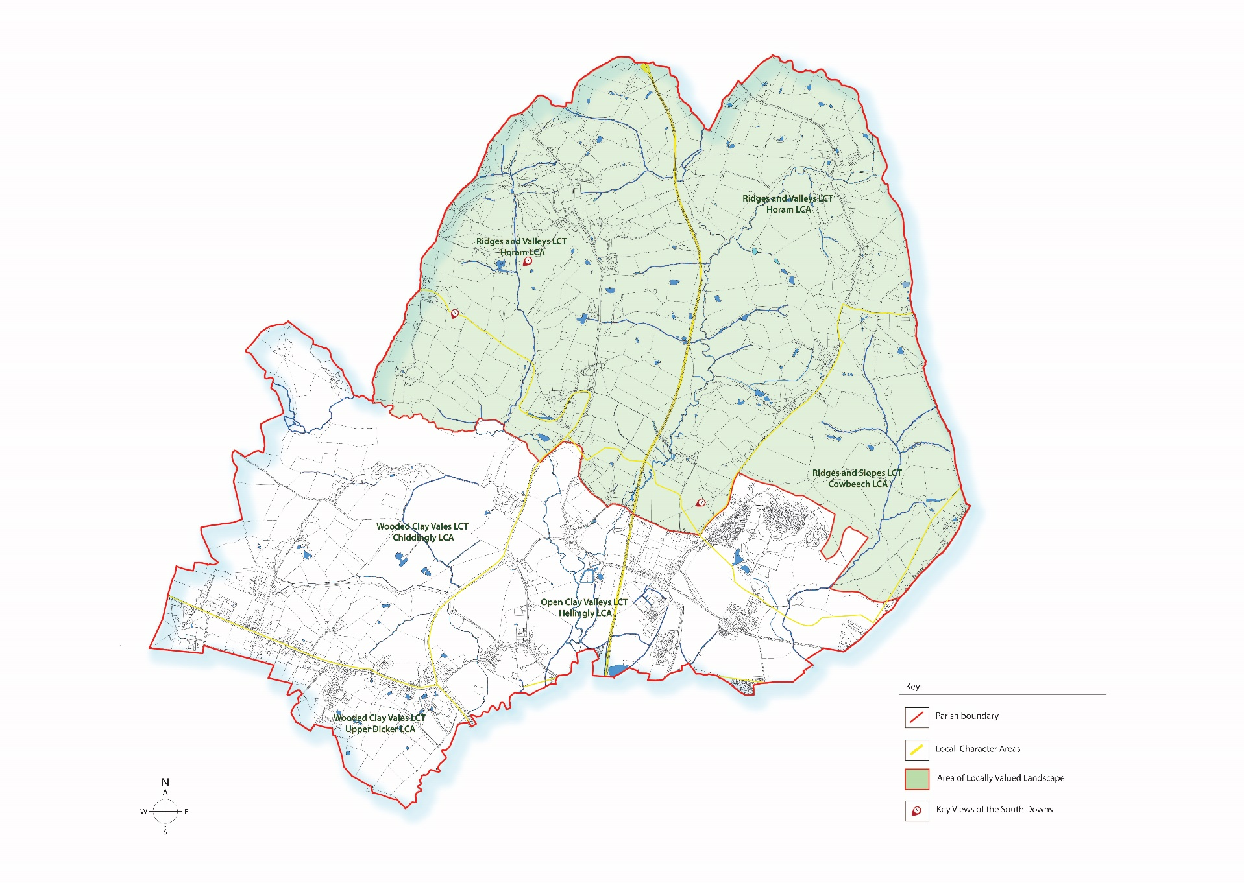
Map 2 – Blue and Green Infrastructure
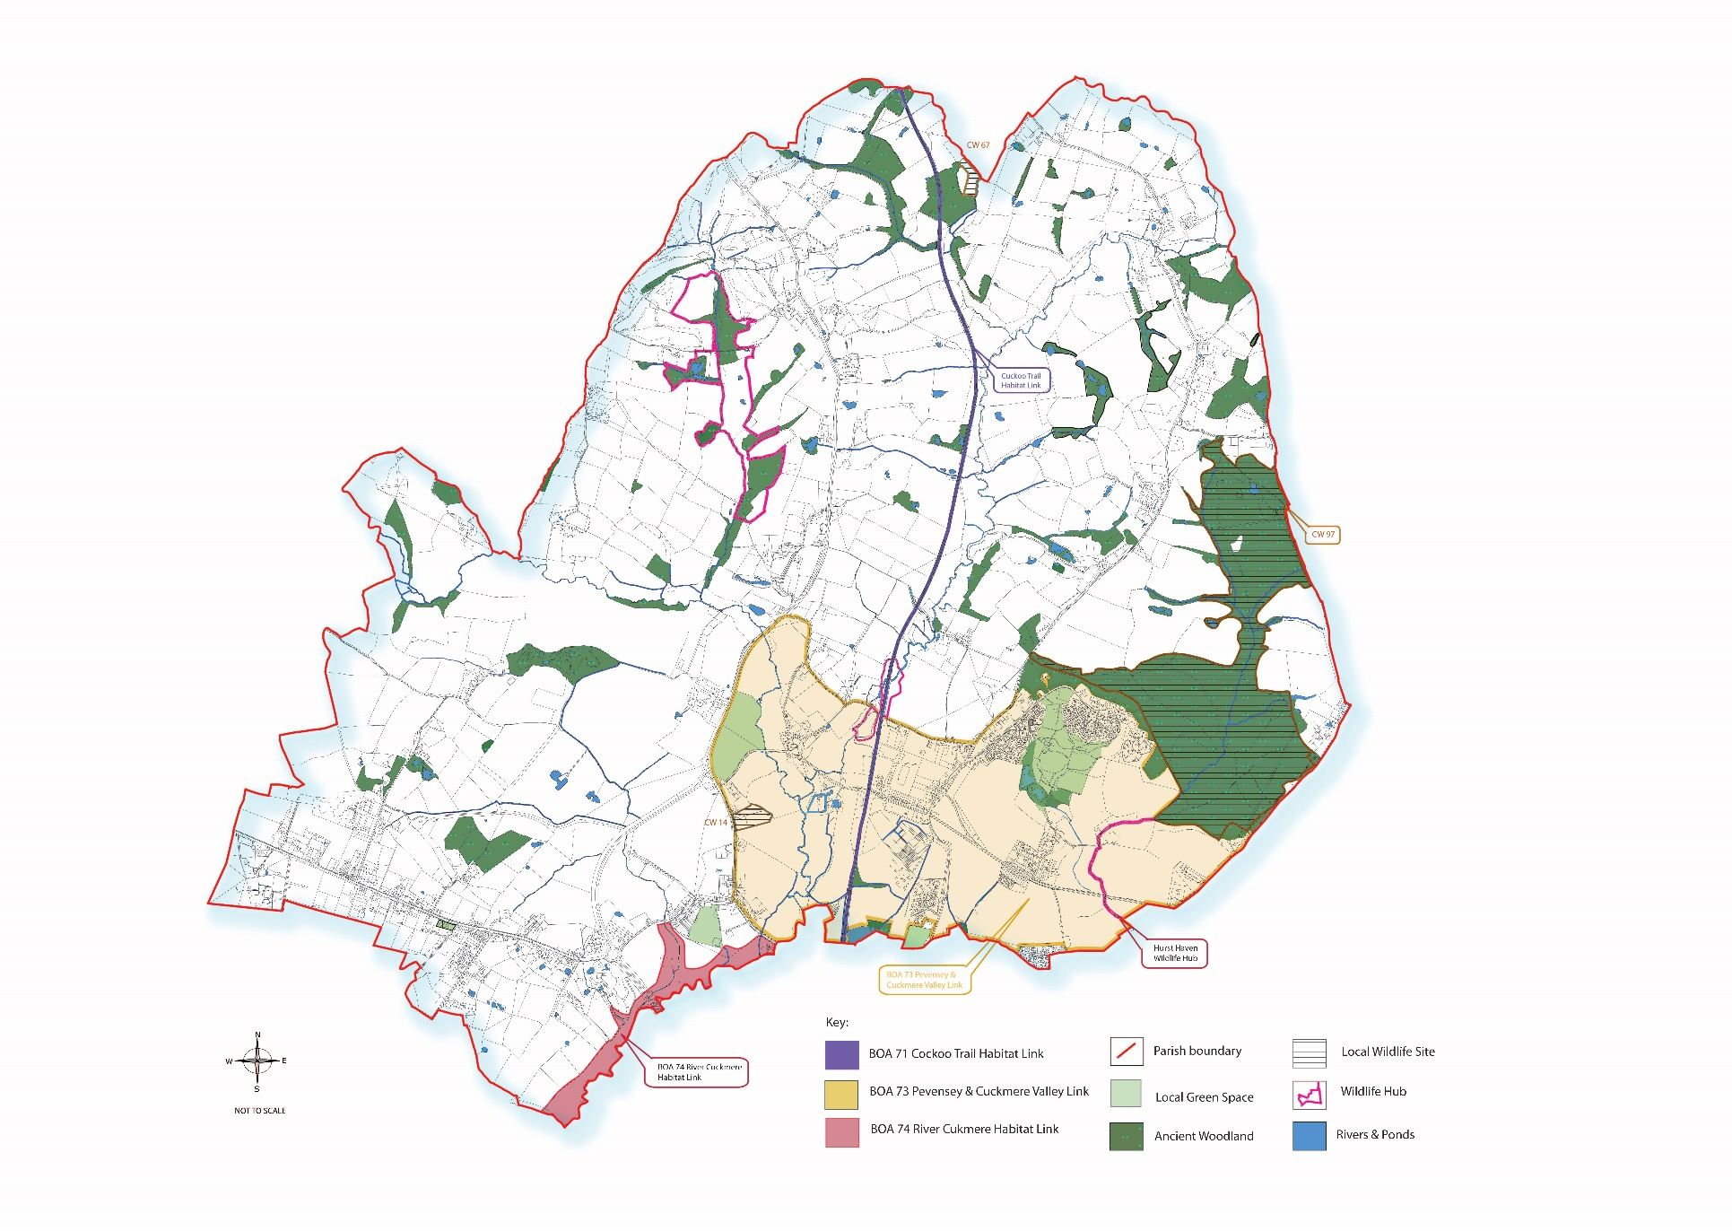
Map 3 – Hellingly Village Area
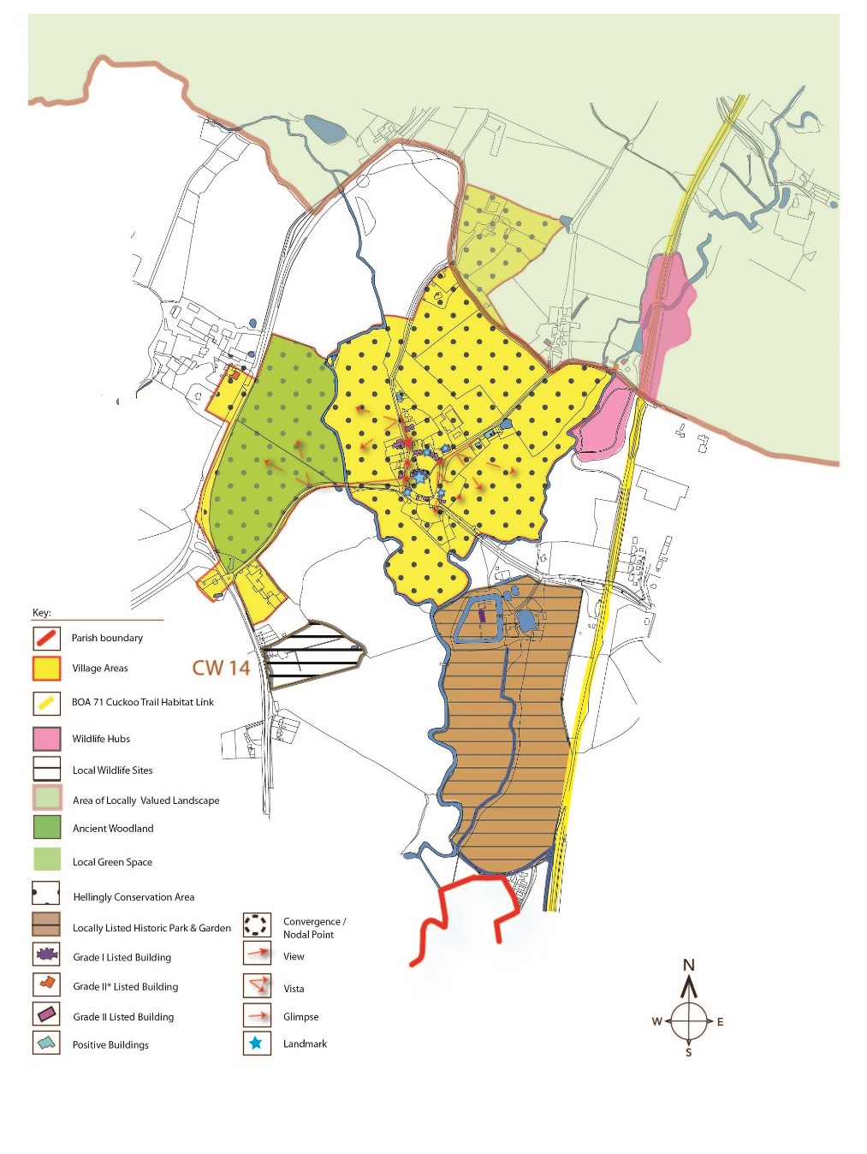
Map 4 – Lower Horsebridge Village Area

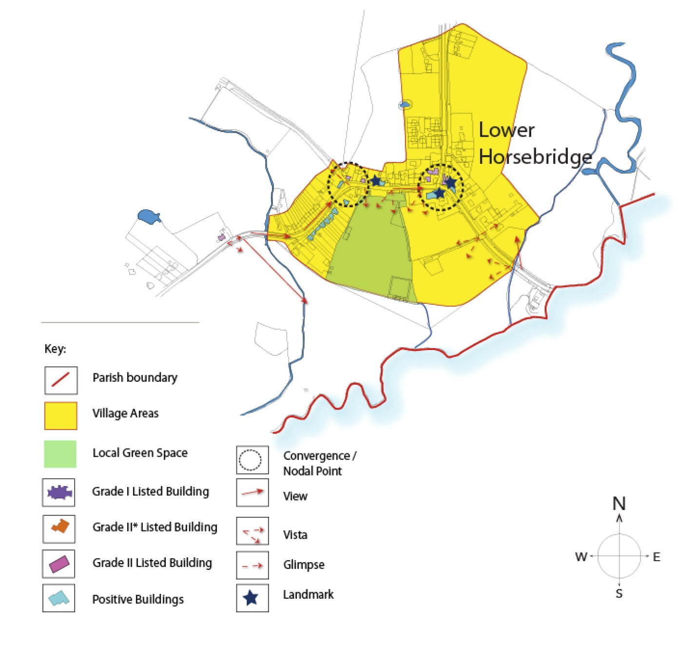
Map 5 – Lower Dicker Village Area

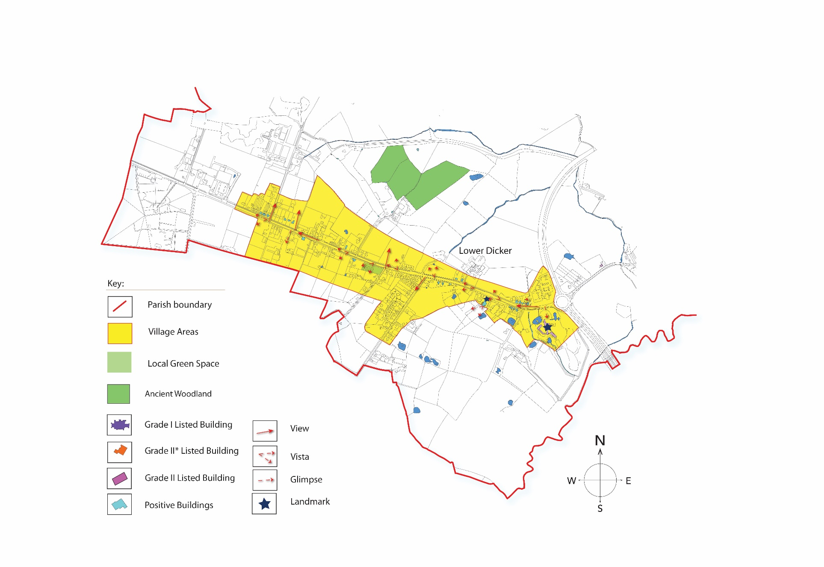
Map 6 – Roebuck Park Village Area

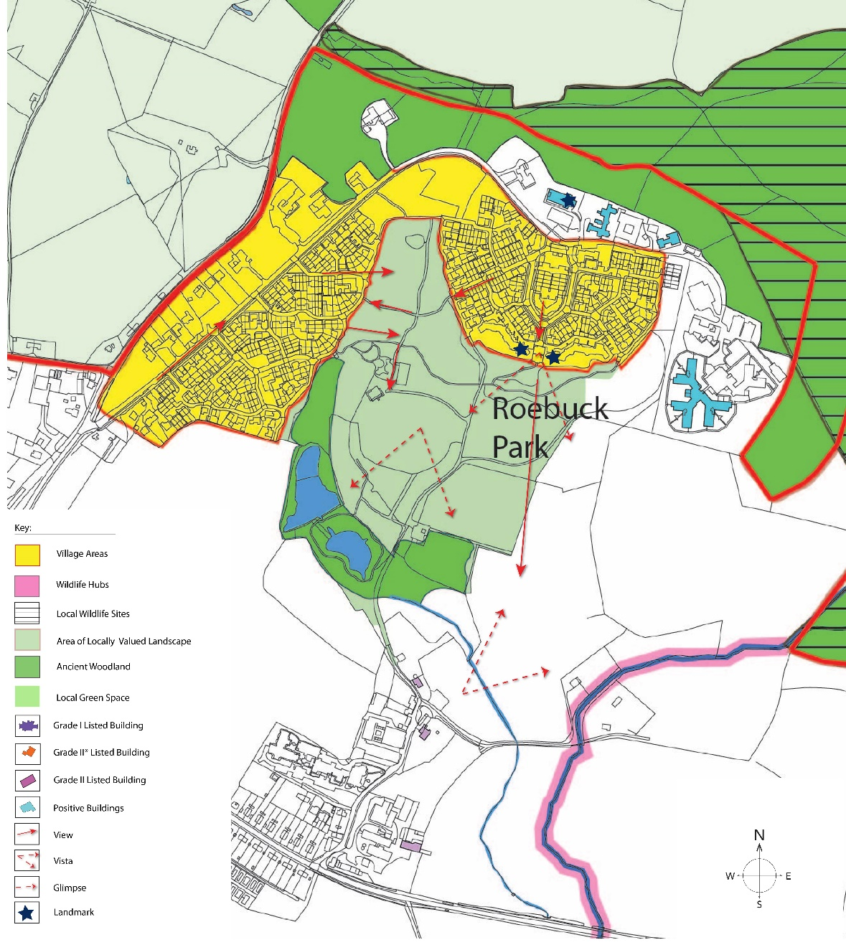
Map 7 – Proposals Map Hellingly Neighbourhood Development Plan

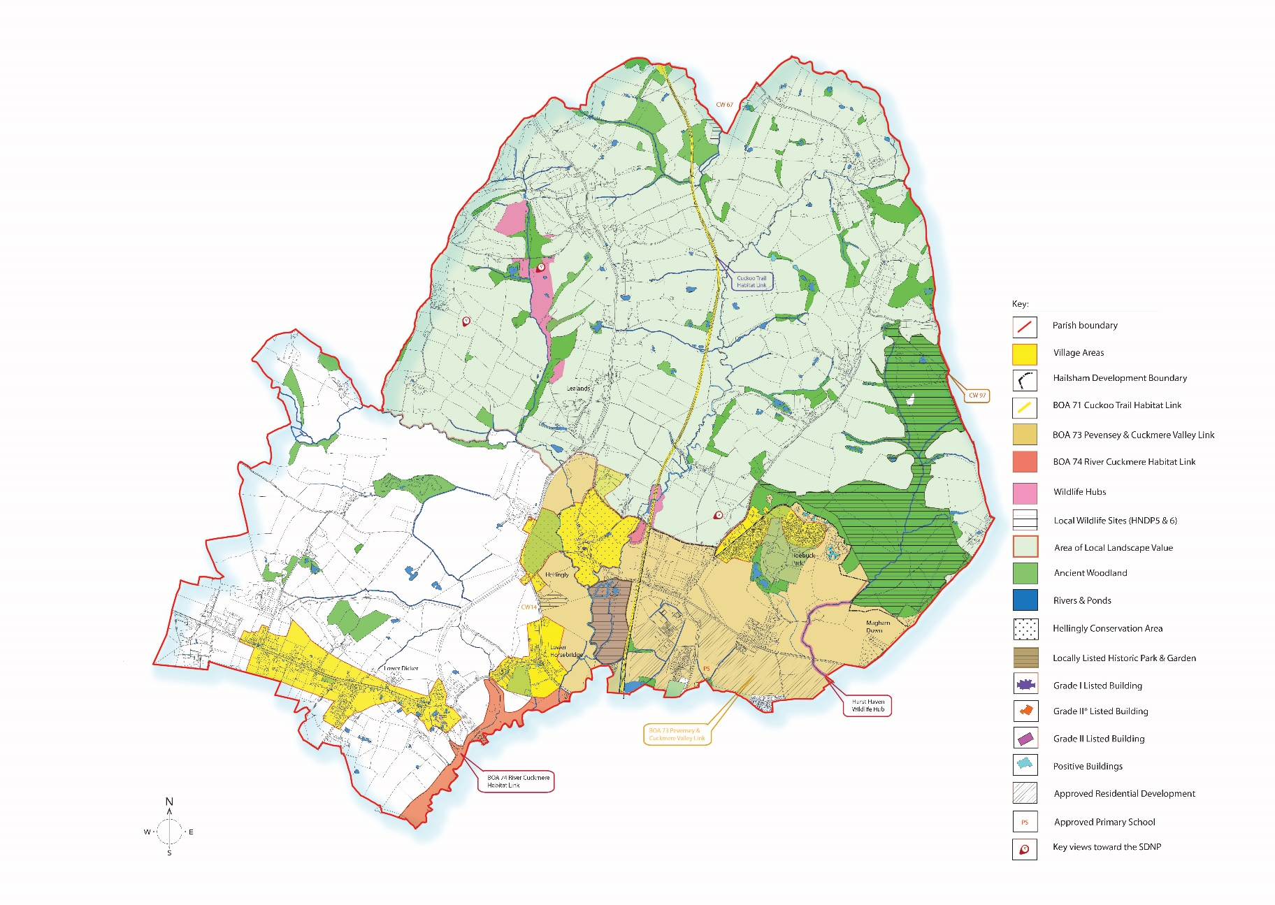
Map A – Locally Designated Green Space – Hellingly Country Park

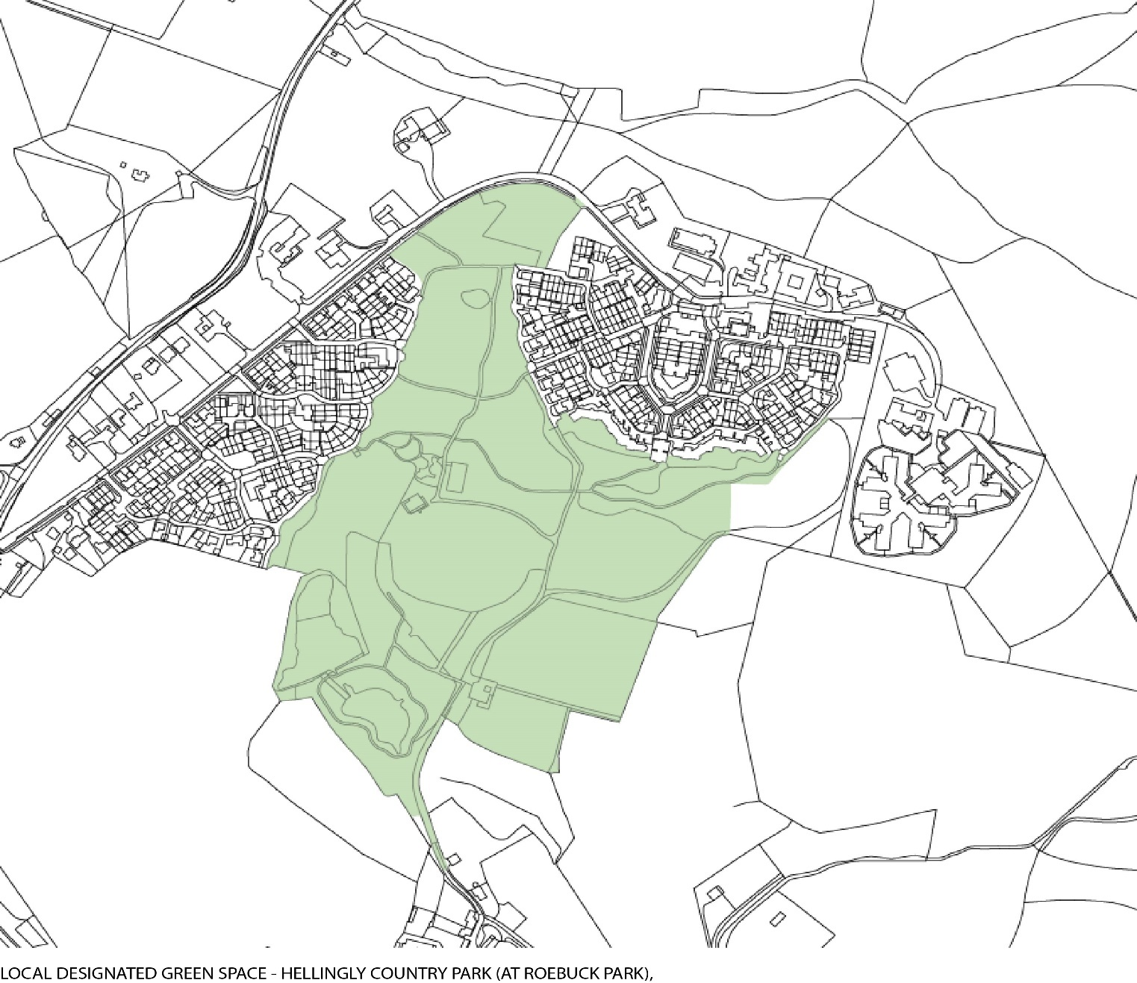
Map B – Locally Designated Green Space – Lower Horsebridge Recreation Ground

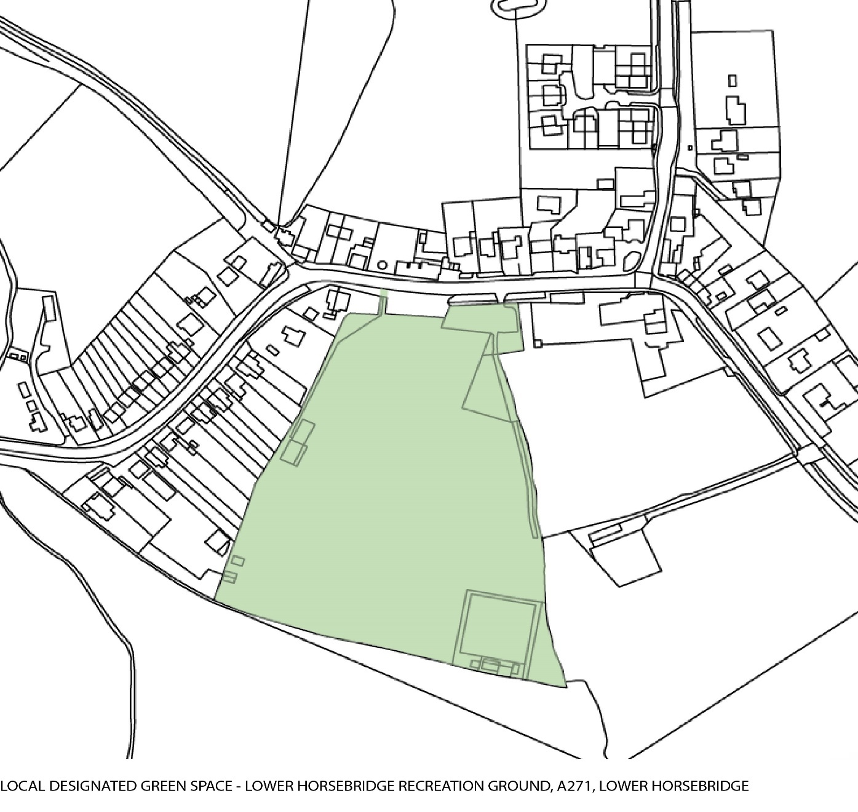
Map C – Locally Designated Green Space – Field Adjacent to Village Hall, Hellingly

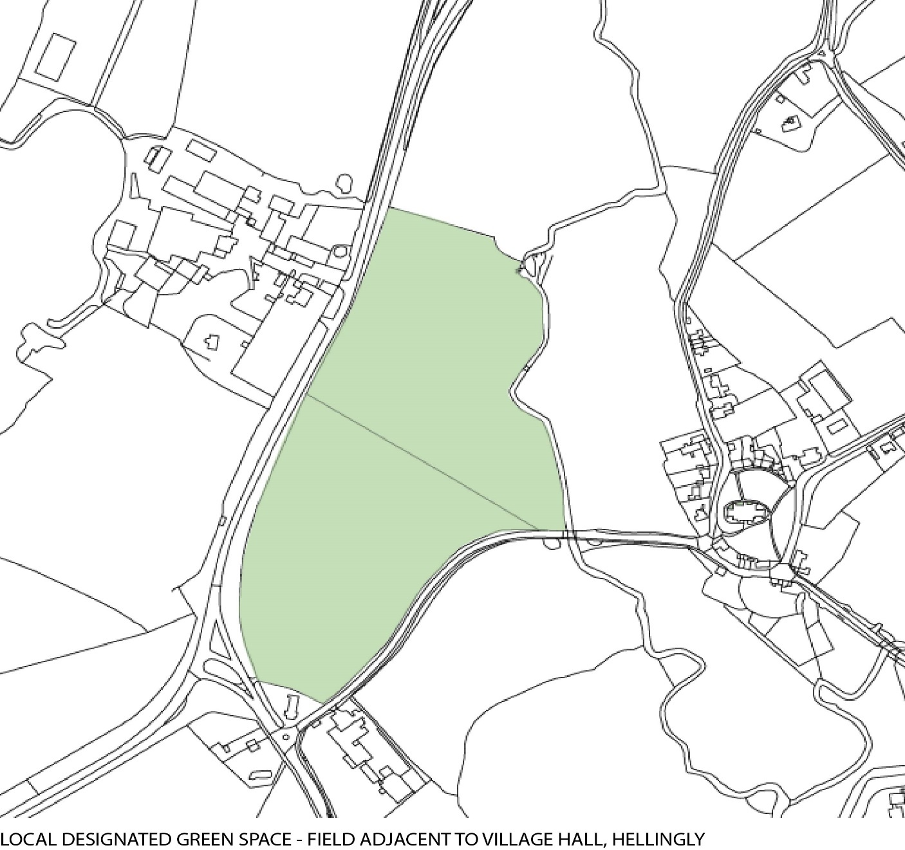
Map D – Locally Designated Green Space – Lower Dicker Cycling and Playground

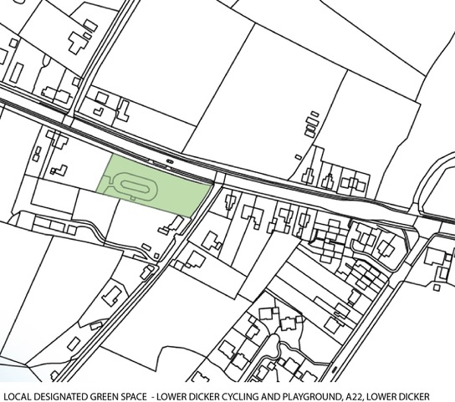

Map E – Locally Designated Green Space – Union Corner Allotments

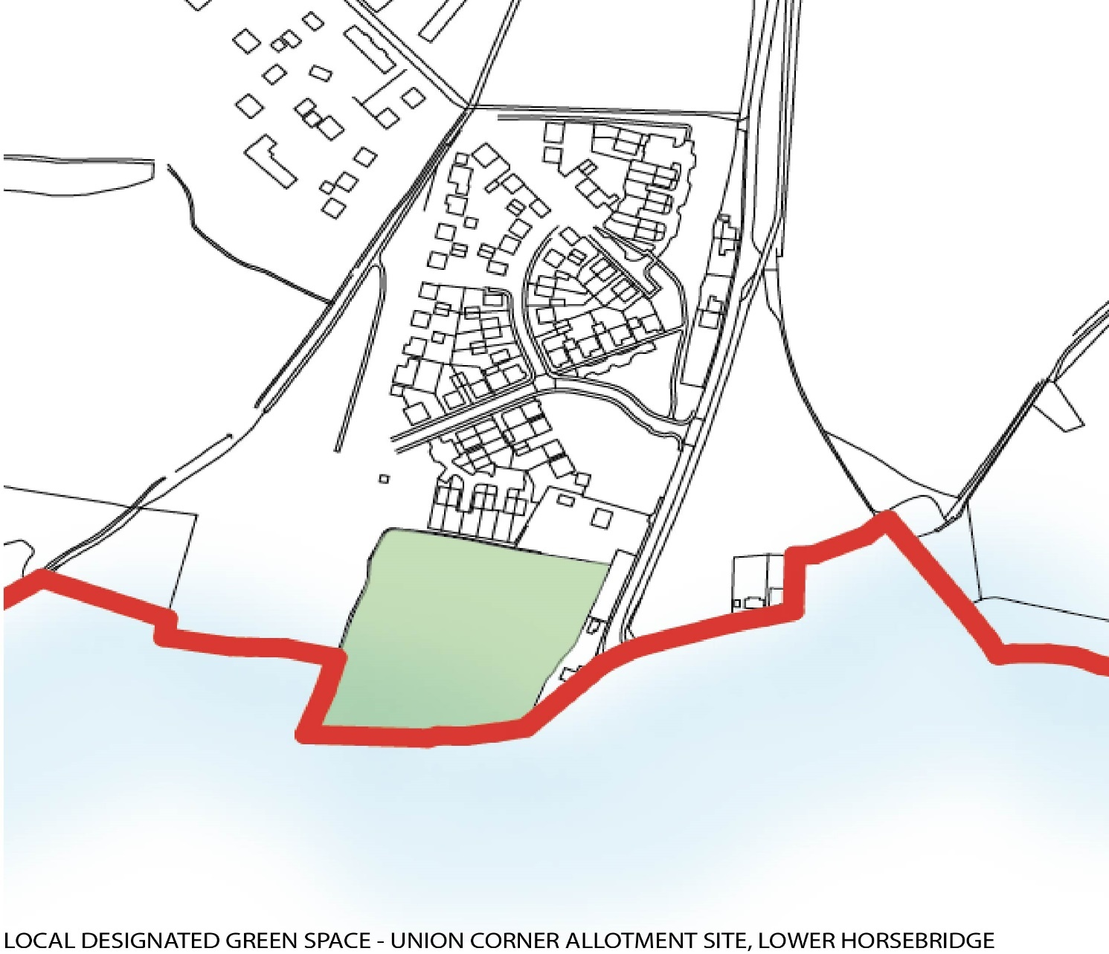

Supporting Papers - HNDP/S2 Public Consultation Phase 1 June 2016 HNDP/S3 Public Consultation Phase 2 Nov 2016
Topic Paper 1 – Hellingly Parish Profile (para. 9)
The Conservation of Habitats, Species and Planning (various amendments) (England and Wales) Regulations 2018
C Blandford Associates 2014
Topic Paper - HNDP/T2 Landscape
Landscape and Ecology Studies – Landscape Partnership 2017
Wealden Green Infrastructure Study – C Blandford Associates 2016
NPPF February 2019 para 170
NPPF February 2019 para 171
Planning 23 March 2018, p29
Planning 22 September 2017, p22
Planning 10 February 2017, p26
NPPF – February 2019 para. 99
Wealden Open Space Study 2016-2028 – Area Profiles Hellingly and Arlington Parish Councils and Hailsham Town Council
NPPF February 2019 para. 100
HNDP Topic Paper 5 – Flooding – 2017
HNDP Topic Paper 8 (i) – Nature Conservation and Biodiversity - March 2017 and HNDP Topic Paper 8 (ii) – Wildlife Hubs and Natural Capital – August 2017
NPPF February 2019 paras 170, 171, 174, 175
HNDP Topic Paper 8(ii) – Wildlife Hubs and Natural Capital – August 2017
HNDP Topic Paper 6 – Farming – April 2017
HNDP Support Paper – Public Consultation Phase 2 – November 2016
NPPF February 2019 – para. 102
Neighbourhood Plan Support Paper HNDP/S3 – Public Consultation Phase 2
NPPF February 2019 – Section 12 Achieving Well Designed Places
Core Strategy Strategic Planning Objective SPO13
Topic Paper HNDP/T7 – Village Character Assessments – July 2017
Town and Country Planning (General permitted Development Order) 2015
HNDP Topic Paper 5 – Flooding – April 2017
HNDP Topic Paper 3 – Heritage Assets – June 2017
Wealden District Council Open Space Study 2016-2028 Area Profile Hellingly and Arlington Parish Councils and Hailsham Town Council Sept 2017
HNDP Topic Paper 7 – Village Character Assessments July 2017
Wealden Open Space Study 2016-2028 – September 2017 – Hellingly, Arlington and Hailsham
HNDP Topic Paper No 4 – Infrastructure – August 2017
HNDP Topic Paper No 4 – Infrastructure para 22 – August 2017

