NEIGHBOURHOOD DEVELOPMENT PLAN

PARISH OF HELLINGLY

STATEMENT OF CONFORMITY

BASIC CONDITIONS REPORT

Town and Country Planning Act 1990 (as amended) Schedule 4B Paragraph 8(2)

MARCH 2019
HELLINGLY NEIGHBOURHOOD DEVELOPMENT PLAN

Introduction

- This Statement has been prepared on behalf of Hellingly Parish Council. It is to accompany submission of the Hellingly Neighbourhood Development Plan (NDP) under Regulation 15 of the Neighbourhood Planning (General) Regulations 2012 to the Local Planning Authority, Wealden District Council.

- Hellingly Parish Council is a qualifying body for the area of the Neighbourhood Development Plan covering the whole of the Parish of Hellingly, as designated by Wealden District Council on 5 November 2015. A map of the area is shown below:

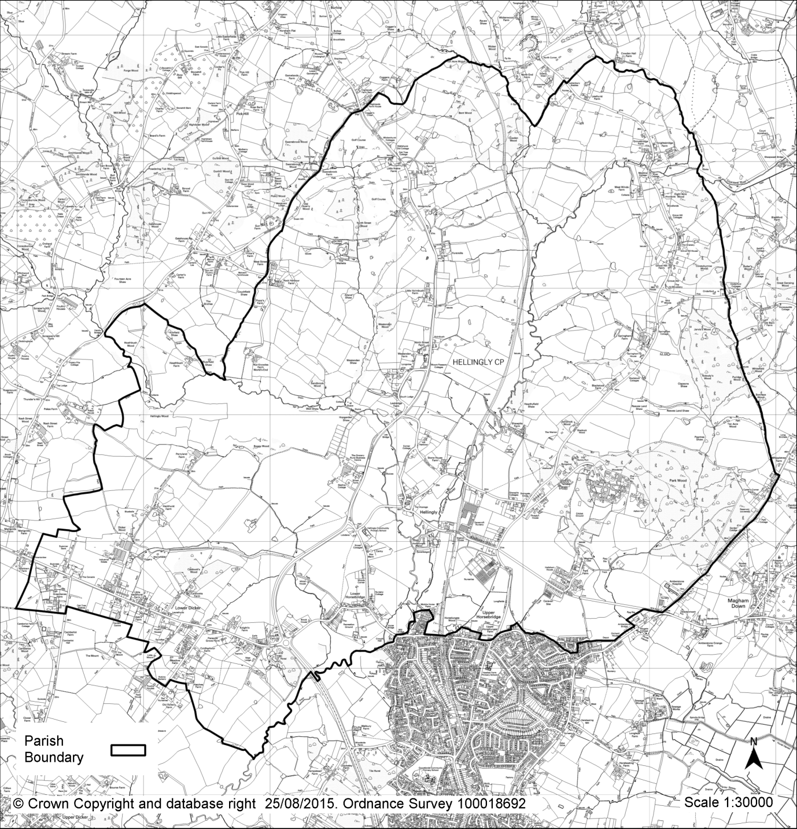

- Policies within the NDP relate to the development and use of land within the designated area and cover the period from 2018 – 2028. This latter date being the date that it is anticipated that the District Council’s emerging Local Plan will run until.

- The regulations state that for a NDP to have met the basic conditions it will need to demonstrate the following:

The Basic Conditions

- That it has had regard to National Planning Policy and advice as issued by the Secretary of State

- That the Plan contributes to the achievement of sustainable development

- That the Plan is in general conformity with the Strategic policies contained in the Development Plan for the area.

- That the Plan does not breach and is otherwise compatible with EU Regulations.

- The NDP contains a number of Policies relating to the development and use of land within the Parish. These are aimed at enabling the local community to shape and influence development in the parish “to give communities direct power to develop a shared vision for their neighbourhood and deliver the sustainable development they need”. (National Planning Policy Framework (NPPF) paragraph 183).

- The Plan has been developed with 2 broad but widely supported aims together with a clearly expressed vision. The Plan has been developed over a period of time and following extensive consultation with residents, business and amenity groups as well as statutory consultees. The Plan also contains a number of Recommendations to service providers. Whilst not having the weight of Policies these need to be addressed in order to ensure that proposed development can be seen as sustainable in the longer term.

- Policies contained within the Plan are aimed at delivering, within a local context, the core planning principles set down within the NPPF covering such matters as rural economic growth, good design, a wide choice of housing types, the promotion of healthy communities, addressing climate change and flooding, and the conservation and enhancement of the natural and historic environment.

- Each policy also references those Development Plan polices which both underpin and are assisted in their delivery, by Policies put forward in this NDP.

- Table 1 is included in this Statement for ease of reference and summarises those elements of the national planning guidance and Development Plan Policies that are relevant to each of the Policies set down in the NDP.

- The following sections of the Statement demonstrate how the Plan meets the basic conditions of Schedule 4B to the 1990 Act. In particular it sets down how it complies with national policy, how it contributes to sustainable development, is in general conformity with the Development Plan for the area and is compatible with EU obligations.

- Since the initial consultations carried out in the production of the NDP and indeed in all subsequent stages of development, it has been acknowledged that the Plan must have regard to National Planning Policy and advice and be in general conformity with the strategic policies set out in the Development Plan for the area. This was set out in early presentations and discussion groups in March/April 2016 (HNDP/S1 refers) and reaffirmed in all consultation stages.

- The NDP must also not breach or be otherwise incompatible with EU obligations including Strategic Environmental Assessment Directive of 2001/42/EC. It must also consider whether it will have any significant effect upon any European site as defined in the Conservation of Habitats and Species Regulations 2017 either alone or in combination with other Plans and projects.

Regard to National Planning Policy and Advice

- In developing the Plan and its Policies close regard has been had to the advice and guidance in the NPPF. Multiple references are included within the text of the Plan to the appropriate sections of the NPPF to show how the Plans policies support and align with National Guidance in promoting sustainable development.

- Examples of this approach can be found in respect of the Policies and proposals for the identification of Areas of Locally Valued Landscape, the designation of Local Green Space, identification of Areas at Risk of Flooding, and importance as Green and Blue Infrastructure. In all cases where relevant detailed reference has been made to the paragraphs principles, objectives and criteria set down in the NPPF to build and develop Policies appropriate for Hellingly.

- The principles set down in the NPPF of promoting sustainable development on environmental, social and economic criteria are supported by those Policies referred to above in addition to others seeking to encourage rural economic growth, farm diversification and a range of housing types.

- Section 2 of the Plan deals in particular with design matters and seeks to retain the identity and character of the individual settlements within Hellingly Parish. This approach is encouraged by the NPPF through its clearly expressed support for good design. Additionally, Policies developed within the NDP in respect of Heritage Assets and non designated Heritage Assets reflect the importance attached to such matters within the NPPF and in respect of statutory provisions of the Planning (Listed Buildings and Conservation Areas) Act 1990.

Compliance with the Development Plan

- A number of relevant policies to the NDP are found in the saved policies of the Wealden Local Plan which was adopted in 1998. This Policy base was added to by Wealden District Councils Core Strategy Local Plan which was adopted in February 2013.

- The District Councils emerging Local Plan was published in March 2017 as a proposed submission version however whilst submission was originally envisaged for autumn 2017 this process has been delayed. Submission now appears unlikely before summer/autumn 2018.

- In respect of this NDP Wealden’s Core Strategy confirmed the removal of Development Boundaries from Lower Dicker and Lower Horsebridge. A full list of those Policies saved from the 1998 Wealden Local Plan is found on the District Council website www.wealden.gov.uk.

- Accordingly, in developing the NDP we have had particular regard to the adopted Development Plan and sought to build upon that Policy base whilst providing the additional local detail and evidence commensurate with Neighbourhood Plans.

- Proposed Policies are identified within the NDP in green shaded boxes. At the end of each are listed those adopted Development Plan policies which support, encourage and promote those matters now embodied within the NDP. Reference is also made where appropriate to relevant Strategic Planning Objectives (SPO) contained within the Core Strategy.

Compliance with European Legislation

- As part of ongoing liaison and dialogue with WDC in preparation of the NDP Wealden as provided particular guidance and advice.

- The NDP has been submitted to the District Council for a screening report in respect of Strategic Environmental Assessment (SEA) and for possible impacts of the Plan upon any European designated sites and for the purposes of compliance with Habitats Regulations. Wealden’s screening opinion confirmed that an SEA should be undertaken and that some of the policies contained in the NDP could be assessed as having a likely significant effect. As such there was an identified need for a Sustainability Appraisal to be carried out in addition to the need for appropriate assessment of the Plan.

- Although not strictly a legislative requirement a scoping report was prepared prior to carrying out the full Sustainability Appraisal (SA) in order that comments from Statutory and other consultees could be considered in the final report. This Scoping Report (October 2018) and the SA itself (December 2018) form part of the submission documents for the NDP. The NDP was submitted to WDC under the Habitats Regulations for its Appropriate Assessment. This assessment dated March 2019 concludes that the most appropriate way of reducing any impacts upon a designated European site is through provision of suitable policy. Such a policy is included in its own right to ensure that the Hellingly NDP is compliant with Habitats Regulations the appropriate assessment report forms part of the submission documents.

- In conclusion the Hellingly Neighbourhood Development Plan is considered to have had appropriate regard to national planning policy guidance and advice as issued by the Secretary of State. The Plan is also considered to be in general conformity with the strategic policies of the Local Development Plan and to support and promote sustainable development through its proposed Policies. It also meets requirements in respect of EU obligations and is not incompatible with human rights legislation.

Hellingly Neighbourhood Plan | Supporting NPPF References | Supporting Development Plan Policies
Policy HNDP 1  Areas of Locally Valued Landscape | Core Principles 1 locally valued, 7 environmental protection  Para 73 access to open space, Para 109 protection of valued landscape,  Para 113 criteria based policies for protection | Core Strategy WCS12, WCS13  Saved Policies EN8, EN12, EN14,EN17
Policy HNDP 2  Local Green Space | Core Principles 1 locally valued, 7 environmental protection, 8 recreational use of land  Paras 69 & 70 promoting healthy communities,  Para 73 access to open space, Para 77 Local Green Space Criteria | Core Strategy SPO11, WCS13  Saved Policies LR1, LR3. LR5
Policy HNDP 3  Areas at Risk of Flooding | Core Principle 6 flood risk  Paras 93, 94,  Para 100 flood risk and avoidance  Paras 101-102. | Core Strategy SPO9, SPO10, WCS14  Saved Policies EN1, EN4
Policy HNDP 4  Minimising Flood Risk | Core Principle 6 flood risk  Paras 93-94,  Para 100 flood risk and avoidance,  Para 101-102. | Core Strategy SPO9, SPO10, WCS14  Saved Policies EN1, EN4
Policy HNDP 5  Green and Blue Infrastructure | Core Principle 7 protection of natural environment  Para 113 criteria based policy for wildlife sites,  Para 114 enhancement and protection of biodiversity networks,  Para 118 biodiversity principles | Core Strategy SPO1, WCS12, WCS13  Saved Policies EN12,EN13,EN14,EN15,EN16
Policy HNDP 6  Biodiversity | Core Principle 7 environmental protection/natural environment  Paras 113 criteria based policy for wildlife sites,  Para 114 enhancement and protection of biodiversity networks,  Para 118 biodiversity principles | Core Strategy SPO1, WCS12, WCS13  Saved Policies EN12, EN13, EN14, EN15,EN16
Policy HNDP 7  Rural Economy | Core Principle 5 supporting rural economies  Para 28 support for rural business | Core Strategy SPO1  Saved Policies DC5, DC6, DC7
Policy HNDP 8  Isolated New Dwellings | Core Principle 5 supporting rural economies  Paras 28 support for rural business,  Para 55 sustainable development in rural areas | Core Strategy SPO1  Saved Policies GD2, DO2, EN27

Hellingly Neighbourhood Plan | Supporting NPPF References | Supporting Development Plan Policies
Policy HNDP 9  Housing Type | Core Principle 3 locally needed housing  Para 47 wide choice of quality homes,  Para 50 housing for future demographic needs | Core Strategy SPO3  Saved Policies HG5
Policy HNDP 10  Sustainable Transport | Core Principle 6 low carbon/reduce future pollution  Paras 29 promotion of sustainable transport,  Para 95 low carbon economy promotion | Core Strategy WCS14, SPO9, SPO7
Policy HV1  Hellingly Village | Core Principles 4 design quality, 5 character  Paras 56-57 high quality design | Core Strategy SPO2  Saved Policies EN19, EN20, EN21, EN22, EN27
Policy HV2  Hellingly Village – Design Criteria | Core Principles 4 design quality, 5 character  Paras 56-57 high quality design | Core Strategy SPO2  Saved Policies EN19, EN20, EN21, EN22, EN27
Policy LHB1  Lower Horsebridge | Core Principles 4 design quality, 5 character  Paras 56-57 high quality design | Core Strategy SPO13  Saved Policies EN14, EN18, EN27, LR1
Policy LHB2  Lower Horsebridge | Core Principles 4 design quality, 5 character  Paras 56-57 high quality design | Core Strategy SPO13  Saved Policies EN18, EN27
Policy LD1  Lower Dicker | Core Principles 4 design quality, 5 character  Paras 56-57 high quality design | Core Strategy SPO13  Saved Policies EN14, EN18, EN27
Policy LD2  Lower Dicker – Design Criteria | Core Principles 4 design quality, 5 character  Paras 56-57 high quality design | Core Strategy SPO13  Saved Policies EN18, EN27
Policy RP1  Roebuck Park | Core Principles 4 design quality, 5 character  Paras 56-57 high quality design | Core Strategy SPO2, SPO13  Saved Policies EN17, EN18, EN27
Policy RP2  Roebuck Park – Design Criteria | Core Principles 4 design quality, 5 character  Paras 56-57 high quality design | Core Strategy SPO2, SPO13  Saved Policies EN27
Policy LHA1  Non Designated Heritage Assets | Core Principle 9 conserve heritage assets  Para 131 Heritage Assets principles  Para 135 non designated Heritage Assets – guidance | Core Strategy SPO2

