BABIES & PRE-SCHOOL GROUPS
Hartbeeps - Classes for babies and toddlers featuring music, puppets, laughter and fun. Thursdays from 9.00am – 2.00pm term time. For more information, please email kim@hartbeeps.com or www.hartbeeps.com

Little Glows East Sussex – Parent Led Sensory Sessions, Thursday’s 10am-1.30pm Term Time. For more information, please contact eastsussex@thelittlesensory.com

Music Bunnies - Fun, interactive and educational!! Fun music with dancing and movement for babies and children aged 0 – 5 years. Tuesday’s 9-1pm.
For more information, please call 07572 378278 or email: info@musicbunnies.co.uk. Website: www.musicbunnies.co.uk

KiddiCity – Mini Role Play City for the under 8’s. A fully mobile role play experience for children aged 1 to 7 years. Dates - 6th,19th Aug / 8th,22nd Sept / 6th,20th, 27th Oct / 3rd, 17th Nov / 1st Dec. For more information, please contact www.kiddicity.co.uk

Happy Jacks – Fun gymnastic based open play sessions. 9-1pm on Saturdays
11th Sept & 2nd Oct. For more information contact www.happyjackssoftplay.co.uk

Fitness Sessions for Mums with babies/toddlers –

SweatyMama – Monday’s 12-2pm (from 5th July)
contact emilyc@sweatymam.com

OLDER CHILDREN/TEENAGE CLUBS & ACTIVITIES
Cerise Performing Arts – Dance & Musical Theatre classes –
Contact Kayleigh @ info@ceriseperformingarts.co.uk
Mon 4.15-5.30pm, Wed 1-2.30pm (pre-school), Sun 9-1.30pm

CMA Karate - Children’s Classes Years 2-6 Fridays 5.30-6.45pm. Youth and Adults Years 7 and above Fridays 7-8.00pm. Contact: Sensei Sarah Padget Tel: 01323 848677
Email: senseisarah@btinternet.com Website: www.cmakarate.co.uk

Girlguiding Visit their website www.girlguiding.co.uk.
3^{rd &} 4th Hailsham Brownies (Ages7-10)– Tuesdays 5.00pm – 6.30pm
1st Hailsham Guides (Ages10-14) – Mondays 6.30-8.00pm

Hellingly Youth Club - Wednesday evenings. School years 6-8 - 5.30pm - 7.00pm. School years 9-11 - 7.30pm - 9.00pm– 11 For more information please visit www.hailshamyouthservice.org or their Facebook and Instagram pages.

HELLINGLY PARISH COUNCIL

What’s On @
THE HELLINGLY
COMMUNITY HUB
The Drive, Hellingly, BN27 4EP
Tel: 01323 449415

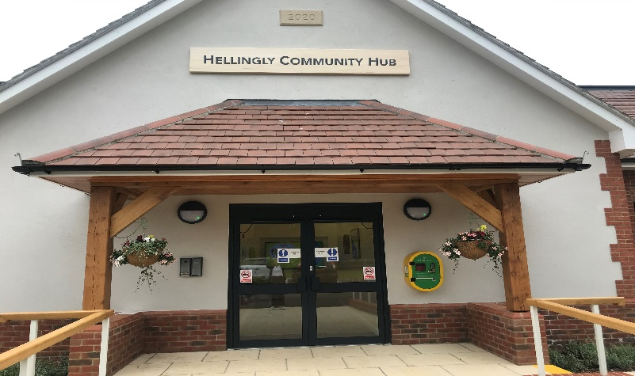

Email: hubbookings@hellingly-pc.org.uk
Website: www.hellingly-pc.org.uk

Join our Hellingly Community Hub facebook page for all our latest information.
ACTIVITIES/GROUPS FOR ADULTS

Yoga with Kate - Mondays: 7-8.00pm– mixed ability, Tuesdays: 10.30-11.30am – gentle/restorative (some chair yoga) For more information please contact Tel: 07990 755415 Email: gregorykate@hotmail.co.uk

Fitness Classes with Hollie - Mondays and Thursdays 5.30-6.30pm. For more information, please contact Hollie @ holliewillispt@gmail.com

Pilates with Jen - Mondays 6.30pm & 7.30pm – Mixed level, Fridays 9.30am.
For more details contact Jen Piper on 07958 519168 or email jen4pilates@aol.com. Website: www.jen4pilates.co.uk

Mission FIIT classes with Kiera –
10-11am Zumba,Tuesday’s 7.00-8.00pm Zumba. (Fridays 5.30-6.30pm Zumba starts 23rd July)
PT sessions also available
For more information, please email kiera1.chambers@hotmail.co.uk

Pilates with Dorota – Thursdays 6.30-7.30pm, Fridays 9.30-10.30am
For more information, please contact dorota.anna.jozwiak@gmail.com

Pole Fitness with Mandy - Come and try out a new and fun way to exercise and keep fit. Thursday evenings at 5.00pm and 6.00pm.
For more information, please contact Mandy on 07917 606952.

Fitness Sessions for Mums with babies/Toddlers – see over page

Hailsham Active – Free Fitness sessions (donations welcome) - Mondays 6pm-8pm outside. For more information, please email andreaattilane@gmail.com or Steve@pro-eco.co.uk or call 07980 643827

Slimming World– Tuesday’s 5-9pm. For more information, please contact edelees@btinternet.com

Short Mat Bowls - Come and have a go at Short Mat Bowls on Tuesday evenings from 7.30pm – 10.00pm. For more information, please contact
Ann Robinson 01323 318696 or email ann-robinson1@sky.com.
Start date Sept 2021

Hellingly Women’s Institute - First Tuesday of every month from 2.00pm – 4.30pm. Please contact Kate Ibbotson on kate@theibbotsons.co.uk or phone 01323 442047. Start date 13th July 2021.
Hailsham and Hellingly Ladies Social Club
Meet on Thursday evenings. For more information phone Mary Little 01323 438720 or Shirley Thomas 01323 507670. Start date 24th June 2021

Hailsham Photographic Society – Meet every Thursday at 7.30pm. Start date 10th August 2021. www.hailshamphotographicsociety.co.uk.

Hailsham Nightingales Women’s Institute – 3rd Thursday of every month from 7.00pm-10.00pm. For more information, please contact Hilary Thomas
Email: wullypully@yahoo.co.uk or Tel: 01323 841411. Start date 15th July 2021.

Hellingly Bowls Club & Bingo Evening – For more information please contact Joy Bennett Email: joy.norman@hotmail.com Tel: 01323 843990 Oct 2021

Hailsham & District Chamber of Commerce – 1st Thursday of every month 07.00-09.00am. Contact Mark Hallett - secretary@hailshamchamber.co.uk

Sunflowers Mental Health & Well-Being Project – A small friendly Group offering support sessions. Wednesday lunchtimes.
For more information contact sunflowersproject@outlook.com
`
MacMillan Cancer Support – Counselling Service here on Fridays.
Contact Lorna Earl to arrange an appointment Tel: 07747 472657
email: lorna.earl@nhs.net

The Hub’s Lending Library is now also open Monday – Friday 9.30-12.30pm. Pop in and help yourselves to our donated Books, DVD’s & Puzzles – new donations also welcome. We also have a public Computer and printer now available for use.

The Hub’s ‘Young at Heart’ Coffee Mornings – Every Monday
“A group for the over 60’s who are young at heart”. Free refreshments.
Support, Advice & Activities or just pop along for a cuppa & a chat.
Table Tennis, Computer Lessons, Arts & Crafts, Board Games, Sunflowers Mental Health Support Group, Dementia Support & Advice, MacMillan Cancer Support, Hailsham Active & much more

SUMMER HOLIDAY ACTIVITY DAYS. Free fun sessions for children of all ages. See our Hellingly Community Hub facebook page for dates and details

WE ARE NOW TAKING BOOKINGS FOR PRIVATE PARTIES, MEETINGS, CHRISTENINGS, FUNCTIONS etc. To check availability, please see our website and complete the booking request page and we will get back to you

