BABIES & PRE-SCHOOL GROUPS
Hartbeeps - Classes for babies and toddlers featuring music, puppets, laughter and fun. Thursdays from 9.00am – 2.00pm term time. For more information, please email kim@hartbeeps.com or www.hartbeeps.com

Music Bunnies - Fun, interactive and educational!! Fun music with dancing and movement for babies and children aged 0 – 5 years. Monday’s 9.30-10.30am & Tuesday’s 9.30-11.30am
For more information, please call Valerie on 07572 378278 or email: info@musicbunnies.co.uk. Website: www.musicbunnies.co.uk

East Sussex Libraries – Combined Rhyme time and Storytime sessions for pre school age. Run every other Thursday (starting from 20th Oct) from 10am till 10:30am For more information contact Rachel on Rachel.gunn@eastsussex.gov.uk

The EnterTRAINment Station - a local business providing hands-on, train themed play sessions for your little ones. Run Once a month – 11th Dec 21 & 15th Jan 22. For further information please contact them on entertrainment-station@hotmail.com

Happy Jacks – Fun gymnastic based open play sessions.
For dates and more information contact www.happyjackssoftplay.co.uk

Fitness Sessions for Mums with babies/toddlers –

Sweaty Mama – Monday’s 12-2pm contact emilyc@sweatymam.com

OLDER CHILDREN/TEENAGE CLUBS & ACTIVITIES

CMA Karate - Children’s Classes Years 2-6 Fridays 5.30-6.45pm. Youth and Adults Years 7 and above Fridays 7-8.00pm. Contact: Sensei Sarah Padget Tel: 01323 848677
Email: senseisarah@btinternet.com Website: www.cmakarate.co.uk

Girlguiding Visit their website www.girlguiding.co.uk.
3^{rd &} 4th Hailsham Brownies (Ages7-10)– Tuesdays 5.00pm – 6.30pm

Hellingly Youth Club - Wednesday evenings. School years 6-8 - 5.30pm - 7.00pm. School years 9-11 - 7.30pm - 9.00pm– 11 For more information please visit www.hailshamyouthservice.org or their Facebook and Instagram pages

Toms Rhinos Sports Club –Sunday mornings - For more information contact info@rhinossportsclub.com

WE ARE NOW TAKING BOOKINGS FOR PRIVATE PARTIES, MEETINGS, CHRISTENINGS, FUNCTIONS etc. To check availability, please see our website and complete the booking request page and we will get back to you
HELLINGLY PARISH COUNCIL

What’s On @
THE HELLINGLY
COMMUNITY HUB
The Drive, Hellingly, BN27 4EP
Tel: 01323 449415

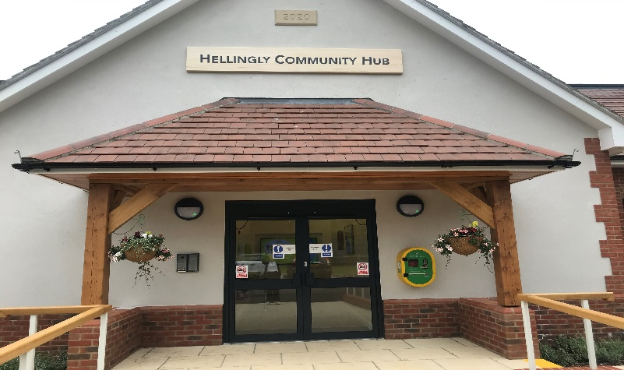

Email: hubbookings@hellingly-pc.org.uk
Website: www.hellingly-pc.org.uk

Join our ‘Hellingly Activities & Facilities’ facebook page for all our latest information.
ACTIVITIES/GROUPS FOR ADULTS

Yoga with Kate - Mondays: 7-8.00pm– mixed ability, Tuesdays: 10.30-11.30am – gentle/restorative (some chair yoga) , Sundays; 10-11am For more information please contact Tel: 07990 755415 Email: gregorykate@hotmail.co.uk

Fitness Classes with Hollie - Mondays 5.30-6.30pm. For more information, please contact Hollie @ holliewillispt@gmail.com

Pilates with Jen - Mondays 6.30pm & 7.30pm, Thursday 7pm-8pm, Fridays 9.30-10:30am .For more details contact Jen Piper on 07958 519168 or email jen4pilates@aol.com. Website: www.jen4pilates.co.uk

Zumba classes with Kiera –
Monday’s 10-10.45am, Tuesday’s 6:30-7:15pm, Fridays 11-11.45am
Zumba PT sessions also available. For more information, please email kiera1.chambers@hotmail.co.uk

Pilates & Gyrokinesis with Leah Jones –
Tuesday mornings @ 11:15am. For more information, contact Leah @ leah@bodyandskinclinic.co.uk or 07735 560570

Pilates with Dorota – Thursdays 6.30-7.30pm, Fridays 9.30-10.30am
For more information, please contact dorota.anna.jozwiak@gmail.com

Pole Fitness with Mandy - Thursday evenings at 5.00pm and 6.00pm.
For more information, please contact Mandy on 07917 606952.

Hailsham Active – Free Fitness sessions (donations welcome) –
Mondays 6-7.00pm & 7-8.00pm. For more information, please email andreaattilane@gmail.com or Steve@pro-eco.co.uk or call 07980 643827

Stretch, Flex & Tone with Jenny West – Friday’s 11.30-12.30pm.
For more information contact Jenny @ jenny_cloisters@yahoo.co.uk or
Tel: 01323 848216

Slimming World– Tuesday’s 5-7.30pm. For more information, please look at their website on www.slimmingworld.co.uk or Jo on 07860 961465

Hailsham Photographic Society – Meet every Thursday at 7.30pm. www.hailshamphotographicsociety.co.uk.

Hellingly Women’s Institute - First Tuesday of every month from 2.15pm – 4.30pm. Please contact Kate Ibbotson on kate@theibbotsons.co.uk or phone 01323 442047.

Hailsham and Hellingly Ladies Social Club
Meet on Thursday evenings. For more information phone Mary Little 01323 438720 or Shirley Thomas 01323 507670.

Hailsham Nightingales Women’s Institute – 3rd Thursday of every month from 7.00pm-10.00pm. For more information, please contact Hilary Thomas
Email: wullypully@yahoo.co.uk or Tel: 01323 841411.

Short Mat Bowls - Come and have a go at Short Mat Bowls on Tuesday evenings from 7.30pm – 10.00pm. For more information, please contact
Ann Robinson 01323 318696 or email ann-robinson1@sky.com.

Hellingly Bowls Club & Bingo Evenings– For more information please contact Joy Bennett Email: joy.norman@hotmail.com Tel: 01323 843990

Hailsham & District Chamber of Commerce – 1st Thursday of every month 07.00-09.00am. Contact Mark Hallett - secretary@hailshamchamber.co.uk

WELLBEING & SUPPORT GROUPS
Sunflowers Mental Health & Well-Being Project – A small friendly Group offering support sessions. Wednesday lunchtime & Monday evening
For more information contact sunflowersproject@outlook.com
MacMillan Cancer Support – Counselling Service
Contact Lorna Earl to arrange an appointment Tel: 07747 472657
email: lorna.earl@nhs.net
Ivy House Dementia Support Group – contact Carlos or Jane on 01323 431801 support@ivyhouse-dementiacare.com

The Hub’s ‘YOUNG AT HEART’ Monday coffee morning
Every Monday 10am-12pm ‘A group for the over 60’s who are young at heart’. Free Refreshments, Support Groups & Advice and weekly activities, or just pop along for a cuppa and a chat.

The Hub’s Lending Library Monday – Friday 9.30-12.30pm. Pop in and help yourselves to our donated Books, DVD’s & Puzzles – donations welcome. Public Computer and printer now available for use.

