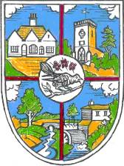 | THE PARISH COUNCIL OF HELLINGLY  The Community Hub, Hellingly, East Sussex, BN27 4EP  Tel: 01323 449415  e-mail: clerk@hellingly-pc.org.uk  Website: www.hellingly-pc.org.uk

You are summoned to a Parish Council Meeting to be held on Wednesday 19th May 2021 at 7.30 pm
At Hellingly Community Hub to transact the following business.

Signed Jenny Hoodless Dated 12th May 2021

Jenny Hoodless, Parish Clerk

AGENDA

- Apologies for absence:

- Questions from Members of the Public.

- Declarations of Interest

- To consider and approve the Minutes of the Parish Council Meeting held by zoom on Wednesday 14th April 2021.

- Matters arising (not covered elsewhere on the Agenda):

- County Councillors Report

- District Councillor’s Report

- Key Council Documents

- Financial Matters. The Council is invited to:

- Neighbourhood Plan Update (Cllr D White)

- Clerk’s report:

- Chairman’s report

