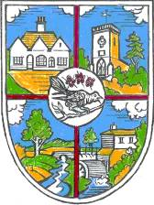 | THE PARISH COUNCIL OF HELLINGLY  The Community Hub, Hellingly, East Sussex, BN27 4EP  Tel: 01323 449415  e-mail: clerk@hellingly-pc.org.uk  Website: www.hellingly-pc.org.uk

You are summoned to a Parish Council Meeting to be held on Wednesday 9th June 2021 at 7.30 pm
At Hellingly Community Hub to transact the following business.

Signed Jenny Hoodless Dated 2nd June 2021

Jenny Hoodless, Parish Clerk

AGENDA

- Apologies for absence:

- Adjournment for input from the public [maximum 15 minutes].

- Declarations of Interest

- To consider and approve the Minutes of the Parish Council Meeting held by zoom on Wednesday 19th May 2021.

- Matters arising (not covered elsewhere on the Agenda):

- County Councillors Report

- District Councillor’s Report

- Financial Matters.

- Clerk’s report:

- Chairman’s report

