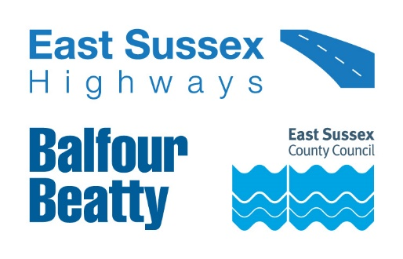

Important Roadworks Information
A22 Hailsham Bypass 18 March 2024
Dear Resident/Business owner,
Balfour Beatty is working in partnership with East Sussex County Council to manage the highways service across East Sussex. As part of this, we will be carrying out multiple sets of works on the A22 Hailsham Bypass.
These works will include road stud replacement, road marking refreshments, joint repair and drainage works.
When do they start?
Work will be carried out between Monday 22 April and Friday 3 May. We will inform you of any changes to the dates or times via advanced warning signs on site.
There are no plans for weekend working during these works.
How will this impact highway users?
The team will be working between the Cophall Roundabout and the Boship Roundabout from 8pm to 6am.
Traffic will be diverted via the A22 Golden Cross, Holmes Hill, Whitesmith, East Hoathly Bypass, Eastbourne Road, Eastbourne Road, Uckfield Bypass, A26 Lewes Road, Rose Hill, Uckfield Road, Malling Hill, Malling Street, Cuilfail Tunnel, Southerham Road, A27 Ranscombe Hill, Lewes Road, Eastbourne Road & vice versa.
These works can not be carried out in phases due to the volume of work being undertaken and the area required to maintain a safe working area for the team on site. We apologise for any inconvenience caused.
If you need vehicle access during the above closure hours, please discuss this with the team on site. Please bear in mind, there will be delays whilst the area is made safe and your vehicle is escorted by site marshals.
Access for emergency vehicles will be maintained at all times.
Information for residents and businesses
Parking: If required, we will put out ‘no parking’ signs and cones on the site to advise where parking is restricted. Please avoid parking in these locations as it will delay our works.
Weather: All these works are subject to favourable weather conditions, for example heavy rain may affect the progress of the works.
Properties close to the carriageway may experience a temporary disturbance as this can be a noisy process and those properties may experience flashing lights and reversing sirens.
Again, we would like to take this opportunity to apologise in advance for any inconvenience or disruption this work may cause, however this forms part of our continuing improvement for the East Sussex highway network.
For information on roadworks and journey planning, visit www.One.Network.com. Please follow us on X (formerly Twitter) @esccroads or Facebook @EastSussexHighways for updates. If you would like to know more about East Sussex Highways and what we do, please visit our website www.eastsussexhighways.com.
Thank you,
East Sussex Highways
Report a problem here: Leave feedback on these works here:

Map of works area
